Annual Report of the Committees established under Sections 11–14 of the Inuvialuit Final Agreement and the Joint Secretariat for the 2018/2019 fiscal year.

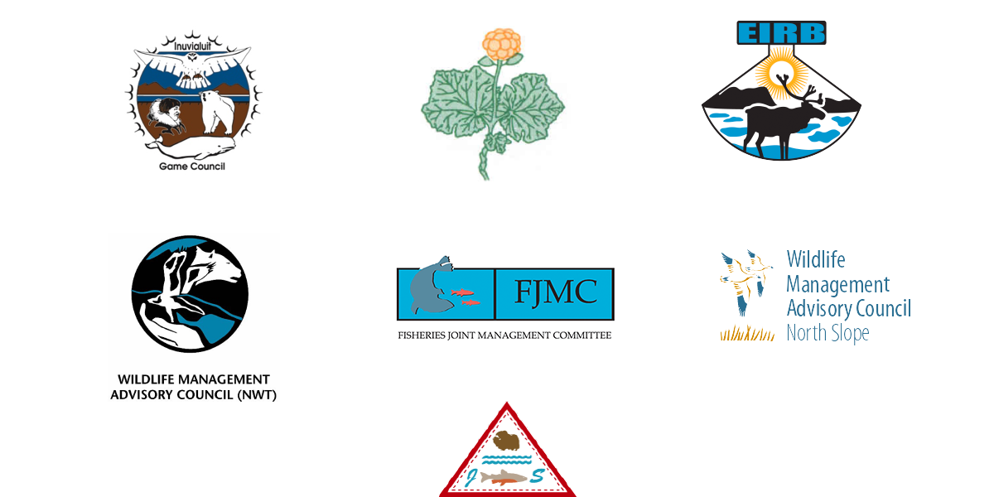

About the Report
Presented here are annual reports for the 2018/2019 fiscal year of five of the six bodies established in Sections 11–14 of the Inuvialuit Final Agreement (IFA), as well as the report of the Joint Secretariat (JS). The reports provide a summary of organizational mandates, membership, finance, and key activities for the year. The six bodies are:
- Inuvialuit Game Council (IGC)
- Environmental Impact Screening Committee (EISC)
- Environmental Impact Review Board (EIRB)
- Fisheries Joint Management Committee (FJMC),
- Wildlife Management Advisory Council – NWT (WMAC (NWT))
- Wildlife Management Advisory Council – North Slope (WMAC(NS))
These bodies are collectively referred to as the IFA committees. Each committee has unique responsibilities defined in the IFA. The efforts of each IFA committee support the effective implementation of the IFA, which is guided by three overarching principles:
- To preserve Inuvialuit cultural identity and values within a changing northern society;
- To enable Inuvialuit to be equal and meaningful participants in the northern and national economy and society; and
- To protect and preserve the Arctic wildlife, environment, and biological productivity.
Sections 11–14 of the IFA describe Environmental Impact Assessment (Section 11: EISC and EIRB); the Yukon North Slope (Section 12: WMAC (NS)); Wildlife Compensation (Section 13); and Wildlife Harvesting and Management (Section 14: IGC, WMAC (NWT), and FJMC). The Joint Secretariat is established as a Society by agreement of the parties to the IFA in order to provide technical and administrative support to the IFA committees.
These annual reports will be incorporated into the yearly Inuvialuit Final Agreement – Implementation Coordination Committee annual report. They will also be used to meet reporting requirements to various funding agencies. For more information on individual committees or the Joint Secretariat, please contact the Joint Secretariat directly or visit the website.
*Please note – the financial information recorded in this version of the report is subject to change based on completion of the Joint Secretariat 2018-19 audit.

Table of Contents
Introduction from Joint Secretariat Chair…………………………………………………………………………………………………1
List of Acronyms and Abbreviations………………………………………………………………………………………………………….2
Report from the Inuvialuit Game Council…………………………………………………………………………………………………5
Report from the Environmental Impact Screening Committee…………………………………………………………..…..13
Report from the Environmental Impact Review Board…………………………………………………………………………..28
Report from the Fisheries Joint Management Committee……………………………………………………………………..43
Report from the Wildlife Management Advisory Council (NWT)……………………………………………………………50
Report from the Joint Secretariat -Inuvialuit Settlement Region……………………………………………………………61

Introduction from Joint Secretariat Chair
  - Submitted by Larry Carpenter – Chair of the Joint Secretariat Board
The 2018/2019 fiscal year was one of significant positive change for the Joint Secretariat (JS). Building on the taking-stock efforts of the previous year, in 2018/2019 we continued implementing organizational changes with largely positive results in matters of human resource management, financial accountability, and overall office culture. The renewed long-term, increased funding arrangement with Canada has allowed committees to better achieve their mandates as described in the IFA. Building on the strong relationships developed over the past few years, it is my hope we can ensure adequate levels of IFA committee funding moving forward.
The Inuvialuit Settlement Region (ISR) environment is continually changing, and the IFA co-management regime must be able to adapt. The impacts of a warming climate on regional ecosystems have Inuvialuit observing incremental changes in many areas. Changes to wildlife migration patterns and their habitat are impacting harvest success. Introduction and proliferation of new and sometimes invasive species are impacting traditional food security. Major landscape change due to permafrost melt is creating challenges for travelers as well as impacts on water quality. The opening up of new shipping routes has resulted in new opportunities for shipping, generally, and the cruise ship industry and recreational vessels, specifically. All of these impacts have placed new challenges before the IFA’s wildlife management and environmental impact assessment committees to try to help mitigate. It is therefore imperative that the relevant institutions established under the IFA be properly supported – be it financially or in other ways – to adequately address the impacts of a warming ISR. I look forward to developing innovative solutions to these challenges with our Inuvialuit and government partners and all regional stakeholders.
Looking ahead to 2019-20, the Joint Secretariat will build on initiatives to ensure more transparency, efficiency, and a positive working environment for our dedicated staff and continue coordination and collaboration with other organizations and agencies.

List of Acronyms & Abbreviations

ACCWM Advisory Committee for Cooperation on Wildlife Management
ANMPA Anguniaqvia niqiqyuam Marine Protected Area
ASFAR Aboriginal Fund for Species at Risk
CA Contribution Agreement
CARMA CircumArctic Rangifer Monitoring and Assessment Network
CEAA Canadian Environmental Assessment Act
CBMP Community-Based Monitoring Program
CIRNAC Crown-Indigenous Relations and Northern Affairs Canada
CMA Conference of Management Authorities
CMAC Canadian Marine Advisory Council
COSEWIC Committee on the Status of Endangered Wildlife in Canada
CPM Committee Program Manager
CWS Canadian Wildlife Service
DEW Distant Early Warning
DFO Fisheries and Oceans Canada
DOEIA – GNWT Department of the Executive and Indigenous Affairs – Government of the Northwest Territories
DOE – YG Department of Environment – Yukon Government
DVIMPF Dolly Varden Integrated Fisheries Management Plan
ECCC Environment Canada and Climate Change
EIA Environmental Impact Assessment’
EIRB Environmental Impact Review Board
EISC Environmental Impact Screening Committee
ENR Environment and Natural Resources
FJMC Fisheries Joint Management Committee
GNWT Government of the Northwest Territories
GRRB Gwich’in Renewable Resources Board
HTC Hunters and Trappers Committee
ICC Inuit Circumpolar Council
IFA Inuvialuit Final Agreement
IGC Inuvialuit Game Council
ILA Inuvialuit Land Administration
IOMP Integrated Oceans Management Plan
IRC Inuvialuit Regional Corporation
ISR Inuvialuit Settlement Region
IT Information Technology
ITH Inuvik-Tuktoyaktuk Highway
JS Joint Secretariat-Inuvialuit Renewable Resource Committees
MPA Marine Protection Areas
MOU Memorandum of Understanding
NT Northwest Territories
NTI Nunavut Tunngavik Incorporation
NS North Slope
PAME Protection of the Arctic Marine Environment
PBAC Polar Bear Administrative Committee
PBTC Polar Bear Technical Committee
PCWG Paulatuk Char Working Group
YG Yukon Government
MOU Memorandum of Understanding
RAs Regulating Agencies
RC Resource Coordinator
RMC Resource Management Coordinator
RP Resource Person
RSEA Regional Strategic Environmental Assessment
RRWG Rat River Working Group
SARC Species at Risk Committee
SRRB Sahtu Renewable Resources Board
TK Traditional Knowledge
TLK Traditional and Local Knowledge
TNMPA Tarium Niryutait Marine Protected Area
UCWG Ulukhaktok Char Working Group
WAMPA Western Arctic Marine Protected Areas
WG Working Group
WMAC (NS) Wildlife Management Advisory Council (North Slope)
WMAC (NWT) Wildlife Management Advisory Council (Northwest Territories)
WRRB Wek’èezhìi Renewable Resources Board
WSWG West Side Working Group
YT Yukon Territory

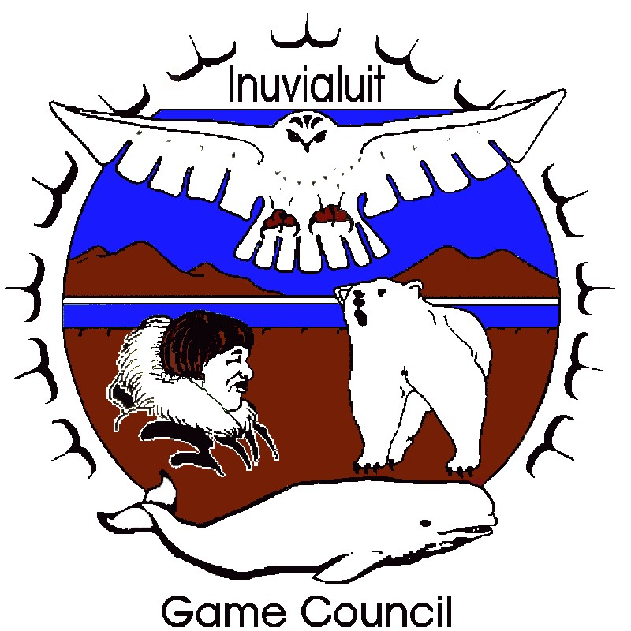

Inuvialuit Game Council
Annual Activity Report

Foreword
The Inuvialuit Game Council (IGC or “the Council”) was established in 1978 and incorporated under the Society Act in 1983 to represent the six Inuvialuit communities of the Western Arctic on wildlife management issues. When the Inuvialuit Final Agreement (IFA) was signed in 1984 and proclaimed through the promulgation of the Western Arctic (Inuvialuit) Claims Settlement Act, the Inuvialuit Game Council acquired a legislated mandate for its activities.
This Annual Activity Report summarizes the activities of the Inuvialuit Game Council during the 2018/2019 fiscal year.

Introduction
Under the Inuvialuit Final Agreement, the IGC represents the collective Inuvialuit interest in wildlife and environmental matters. The Council derives its mandate from Section 14(74) of the Inuvialuit Final Agreement (see Appendix A). The Council is one of the major Inuvialuit organizations established to implement the Inuvialuit Final Agreement and works in parallel with the Inuvialuit Regional Corporation (IRC).
The Council is responsible for upholding and administering Inuvialuit harvesting rights acquired under the Inuvialuit Final Agreement. The Council also has a mandate to represent the collective Inuvialuit interest in all matters related to renewable resource management in the Inuvialuit Settlement Region (ISR) (see Figure 1).
The Council appoints Inuvialuit representatives to all of the joint wildlife and environmental co-management committees established under the IFA. In addition to its responsibilities under the Inuvialuit Final Agreement, the IGC acts as the regional representative of Inuvialuit hunters, trappers, and fishermen.

Membership and Officers
The Inuvialuit Game Council was established in 1978 and incorporated under the Society Act in 1983 to represent the six Inuvialuit communities of the Western Arctic on wildlife management issues. When the Inuvialuit Final Agreement (IFA) was signed in 1984 and proclaimed through the promulgation of the Western Arctic (Inuvialuit) Claims Settlement Act, the Inuvialuit Game Council acquired a legislated mandate for its activities.
The IGC is comprised of two representatives from each of the six Inuvialuit Hunters and Trappers Committees (HTCs). Each HTC appoints from its Board an IGC Director – the voting member – and an IGC Alternate, who may or may not be an HTC Director. The IGC Chair is elected by all 42 HTC Directors.
The Inuvialuit Game Council is incorporated as a Society under the Northwest Territories Societies Act and is required to elect Officers.
  - Membership and Officers of the Inuvialuit Game Council during 2018/2019
Community | Position | Name
Sachs Harbour | Chair | Vernon Amos (August 2018- October 2022)
Aklavik | Director | Jordan McLeod
 | Alternate | Dean Arey (to December 2018)  Billy Archie (from January 2019)
Inuvik | Director and Treasurer | Hans Lennie
 | Alternate | Jimmy Kalinek
Tuktoyaktuk | Director | Charles Gruben (to December 2018)  Jim Elias (from January 2019)
 | Alternate | Richard Gruben
Paulatuk | Director | Lawrence Ruben (and Vice-Chair to December 2018)  Joe Illasiak (from January 2019)
 | Alternate | Joe Illasiak, Lawrence Ruben
Sachs Harbour | Director and Vice-Chair (from March 2019) | Manny Kudlak
 | Alternate | Warren Esau
Ulukhaktok | Director | Joseph Haluksit (to December 2018)  David Kuptana (from January 2019)
 | Alternate | John Alikamik

IGC Activities During 2018/2019

Directors’ and Regular Meetings
The IGC held all four of its quarterly board meetings in June, September, and December 2018, and March 2019.

Meetings Attended by Inuvialuit Game Council Members or Appointed Representatives
In addition to the IGC quarterly meetings, IGC Chair and Directors attended, participated and presented at a number of meetings and conferences including:
- Inuvialuit Final Agreement 101 workshop– Inuvik, NT
- Tuk Pen / Cape Bathurst Calving Grounds protection meeting – Tuktoyaktuk, NT Yukon
- Regional Strategic Environmental Assessment (RSEA) Community Tour – multiple communities
- ICC Alaska Food Sovereignty Advisory Committee – Nome, AK
- Inuvialuit Final Agreement – Implementation Coordinating Committee – teleconferences, Inuvik, NT
- Porcupine Caribou Summit II and III– Inuvik, NT and Dawson, YT
- NWT Pests, Pathogens, and Invasive Species Symposium – Yellowknife, NT
- Beluga tagging co-design workshop – Inuvik, NT
- ORCA 2018 meeting – Ottawa, ON
- Inuvik-Tuktoyaktuk Highway Corridor working group – Inuvik, NT
- Polar Bear Advisory Committee – Moose Jaw, SK
- National Advisory Panel on Marine Protected Area Standards – Inuvik, NT
- Workshop on Climate Change Adaptation and Protected Areas – Yellowknife, NT
- Inuit Circumpolar Council Food Sovereignty Workshop – Tuktoyaktuk, NT
- ISR Shipping Coordination Workshop – Inuvik, NT
- Proactive Vessel Management – Gatineau, QC
- Light Goose Management Workshop – Winnipeg, MB
- Porcupine Caribou Management Board Native User Agreement Meeting - Dawson, YT
- Boreal Caribou Range Planning Framework – Yellowknife, NT
- NSERC Permafrost Network planning meeting - Whitehorse, YT
- Arctic Shipping North America - St John’s, NL
- Beaufort Sea Partnership - Inuvik, NT
- NWT Wildlife Act s.15 and Working Group - Yellowknife, NT
- North American Caribou Workshop - Ottawa, ON
- COSEWIC Status Meeting - Ottawa, ON
- CMAC Meeting - Yellowknife, NT
- Beluga tagging tour - All ISR communities
- ArcticNet - Ottawa, ON
- FJMC Meeting – Winnipeg, MB
- Dolphin & Union Caribou user-to-user meeting – Edmonton, AB
- Inuvialuit – Inuit Polar Bear Commission – Edmonton, AB
- Polar Bear Technical Committee – Edmonton, AB
- Porcupine Caribou Management Board Annual Harvest Meeting – Inuvik, NT
- RSEA ISR Small Vessel Risk Assessment Steering Committee Meeting – Halifax, NS
- ICC Alaska Food Sovereignty and Self Governance Youth & Elders Meeting – Bethel, AK
- ICC Alaska Food Sovereignty and Collective Meeting – Bethel, AK
- Regional Coordinating Committee Meeting – Inuvik, NT
- 2nd International Workshop on Beluga Whale Research & Conservation – Mystic, CT
- PAME MPA workshop: “Exploring ways to support Indigenous/Local involvement in, and Indigenous/Local led, marine protection in the circumpolar Arctic Ocean”
- Government of the Northwest Territories Environment and Natural Resources Traditional Knowledge and Sustainable Livelihoods Action Plans Meeting – Inuvik, NT
- Tuktoyaktuk Peninsula & Cape Bathurst Calving Grounds Working Group Meeting – Inuvuik, NT
- Proactive Vessel Management Pilot Site Meeting – Inuvik, NT

Committee Summaries and Activities During 2018/2019
Over the years, committees were established to implement provisions of the Inuvialuit Final Agreement and to deal with on-going issues (including national and international issues) related to the management of wildlife species that directly or indirectly affect the Inuvialuit of the Western Arctic. These committees are separate from the co-management structures established under the Inuvialuit Final Agreement (IFA).
Below is a list of the committees to which the IGC has appointed members and alternates, including the co-management committees established under the IFA, during the 2018/2019 fiscal year. Also listed is the length of members’ terms.
IGC Committee Appointments
Committee | Directors | Term end | Alternates | Term end
Wildlife Management Advisory Council (NWT) | Dennis Arey | 09/21 | Dang Dang Gruben | 09/20
 | Bradley Carpenter | 09/21 | Joshua Oliktoak | 09/19
 | Jimmy Kalinek | 09/20 | Paul Voudrach | 09/20
Wildlife Management Advisory Council (North Slope) | Danny C. Gordon | 09/20 | Michelle Gruben | 09/20
 | Ernest Pokiak | 09/19 | Gerry Kisoun | 09/19
Fisheries Joint Management Committee | John Noksana | 09/21 | Richard Binder | 09/21
 | Gerald Inglangasuk | 09/19 | Joshua Oliktoak | 09/19
Environmental Impact Review Board | Roland Kikoak | 09/20
 | Ethel Gruben | 09/21
 | Crystal Lennie | 09/19
Environmental Impact Screening Committee | Ray Ruben Sr | 09/19
 | Shannon O'Hara | 09/19
 | Gerald Inglangasuk | 09/21
Cumulative Impact Steering Committee | Dennis Arey | 09/21
Inuvialuit-Inupiat Beluga Joint Management Committee | Dean (Manny) Arey | 09/21
 | John Noksana Jr | 09/20
 | Jimmy Kalinek | 09/20
Porcupine Caribou Management Board | Billy Storr | 09/20 | Dean (Manny) Arey | 09/20
Tuktut Nogait National Park Management Board | Noel Green | 09/20 | John M. Kudlak | 09/19
Polar Bear Technical Committee | John Lucas Jr | 09/20 | Jimmy Kalinek | 09/20
Inuvialuit-Inupiat Polar Bear Joint Commission | Lennie Emaghok | 09/22 | James Pokiak | 09/20
 | John Lucas Jr | 09/20
IFA Implementation Coordinating Committee | Vernon Amos | 10/22
 | JS Executive Director (interim: Cheryl Williams/Jen Lam)
Inuvialuit-Nunavut Polar Bear Joint Commission | Fred Akoaksion | 09/21 | Manny Kudlak | 09/20
 | Gibson Kudlak | 09/19
 | Stan Ruben | 09/19
Dall's Sheep Management Plan Working Group | Billy Storr | non-determinant
Inuvialuit Harvester Assistance Program Review Committee | Jimmy Kalinek | non-determinant
 | Fred Akoaksion | non-determinant
RSEA ISR Small Vessel Risk Assessment Steering Committee | Hans Lennie | duration of project

Funding Summary
Implementation Funding: $627, 890. Received from the Government of the Northwest Territories.
Implementation funding is used to carry out core functions of the Inuvialuit Game Council as described throughout this report.

Inuvialuit Game Council Highlights Summary
Inuvialuit Game Council (IGC) members or representatives attend meetings that address issues related to the IGC’s mandate regarding wildlife and habitat in the ISR at the community, territorial, national, and international levels. The list of meetings that IGC members or their representatives attended and the committee summaries included in this annual report indicate a number of the issues in which the Game Council was involved. The following are highlights of Inuvialuit Game Council activities during the 2018/2019 fiscal year.
The Inuvialuit Final Agreement (IFA) was signed over 30 years ago, but many older (and some newer) pieces of government legislation do not reflect the harvesting rights of the Inuvialuit. Although the IFA supersedes existing and future legislation to the extent of any inconsistency, the IGC feels that it is important to ensure that when legislation is being written or amended, it is made consistent with the IFA. With that in mind, the IGC provides ongoing input into various territorial and national Acts and Regulations.
In addition to attendance at the aforementioned meetings, the IGC has lead or partnered in a number of regional initiatives to address wildlife and wildlife habitat management in the Inuvialuit Settlement Region (ISR). These include:
Beaufort RSEA
Ongoing coordination with IRC, INAC and federal departments through ISR RSEA Coordinator. The IGC is one of the co-chairs of this initiative. The RSEA website is now live at: http://rsea.inuvialuit.com
The RSEA team went on a community tour in March 2019 that focused on outreach and reporting activities back to the communities.
ISR Shipping Coordination
IGC hosted a shipping workshop with involvement of all the Inuvialuit co-management boards, community organizations and the relevant government agencies to get everyone on the same page regarding shipping issues in the ISR. The workshop outcomes have been presented at numerous forums to inform federal agencies how the Inuvialuit would like to engage on shipping issues. This includes at Arctic Shipping North America, Beaufort Sea Partnership, and the Canadian Marine Advisory Council. IGC continues to have conversations with TC and CCG regarding the OPP program, and Proactive Vessel Management. A working group with JS and IRC staff membership has also been formed and is working towards finalizing the Inuvialuit Environmental Shipping Guidelines.
Federal Legislative Reviews and other federal reviews
The IGC continues to be engaged in a number of Federal Legislative reviews and Standing Committee reviews regarding the Fisheries Act, CEAA and Marine Protected Areas and have made submissions jointly with IRC on a number of them.
Beaver management
IGC has been working with WMAC(NWT) and the Inuvik, Aklavik, Tuktoyaktuk, and Paulatuk HTCs to develop a beaver management program. This program is in its second year. WMAC(NWT) and IGC released a joint FAQ and harvester information poster in late May. The IGC Chair spoke to CBC to clarify the intent and activities undertaken as part of the program. IGC, WMAC(NWT) and ENR continue to work with the HTCs on this initiative.
Beluga Tagging Project
The Beluga Tagging Project was developed based on direction from the IGC. The Council, FJMC, JS Staff and DFO are collaborating on this project to tag whales off of Hendrickson Island for a second season in summer 2019. The IGC co-hosted a Co-Design Tagging Workshop to ensure that Inuvialuit input and TK were involved in the tagging protocols and design of hunter-deployed harpoon tags. JS staff have launched a Beaufort Sea Beluga Facebook Group to help share the information regarding this project and belugas in general. HTCs are encouraged to join this Facebook group.
Inuvialuit-Inupiat Polar Bear and Beluga Whale Joint Commission meetings
The IGC hosted the I-I meetings in Edmonton in August 2018. This year marked the 30th anniversary of the signing of the Inuvialuit-Inupiat Polar Bear Joint Commission Agreement. The commissioners provided recommendations regarding next steps research and management.
Dolphin & Union Caribou User-to-User Meetings
The IGC and WMAC(NWT) were recipients of funding from the Aboriginal Fund for Species at Risk to facilitate user-to-user meetings regarding the management of this territorially and federally-listed species at risk. Representatives from Nunavut and the ISR attended a meeting in February to discuss next steps for collaborative transboundary management of the species.
Tuktoyaktuk Peninsula and Cape Bathurst Calving Grounds
The IGC and WMAC(NWT) are co-hosting working group meetings to put together a position paper on the Inuvialuit perspective regarding the identification and management of sensitive habitat for these barren-ground caribou herds within the Inuvialuit Settlement Region.

Appendix A. Inuvialuit Game Council’s Role under the Inuvialuit Final Agreement
Section 14 (73)
The Inuvialuit Game Council shall be established and shall have a Chairman and at least one representative from each of the Hunters and Trappers Committees referred to in subsection(75).
As amended January 15, 1987
Section 14 (74)
For the purposes of this Agreement, the Inuvialuit Game Council shall represent the collective Inuvialuit interest in wildlife. Without limiting the generality of the foregoing, the Inuvialuit Game Council shall, among its other activities:
(a) appoint Inuvialuit members for all joint government/Inuvialuit bodies having an interest in wildlife, including those referred to in Sections 11, 12 and 14;
As amended January 15, 1987
(b) advise the appropriate governments through the Wildlife Management Advisory Councils (NWT and North Slope) or otherwise as appropriate on policy, legislation, regulation and administration respecting wildlife, conservation, research, management and enforcement;
(c) assign community hunting and trapping areas within the Inuvialuit Settlement Region for the purposes of Inuvialuit wildlife harvesting where appropriate;
(d) review and advise through the Wildlife Management Advisory Councils (NWT and North Slope) or otherwise as appropriate, the appropriate governments on existing or proposed wildlife legislation;
(e) review and advise the government on any proposed Canadian position for international purposes that affect wildlife in the Inuvialuit Settlement region;
(f) where appropriate, allocate Inuvialuit quotas among the communities;
(g) appoint members whenever possible or appropriate for any Canadian delegation that deals with international matters affecting wildlife harvesting by the Inuvialuit.
(h) appoint members for any committee or group whose purpose is to investigate any aspect of wildlife usage in the Inuvialuit Settlement region; and
(i) on request, assist the Wildlife Management Advisory Councils (NWT and North Slope) in carrying out their functions.

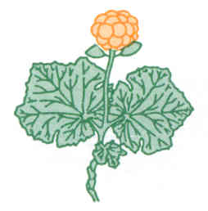
Environmental Impact Screening Committee
Annual Activity Report

Foreword
As the Chair of the Environmental Impact Screening Committee (EISC) I am pleased to present the EISC’s 2018-2019 Annual Report.

Section 11 of the Inuvialuit Final Agreement (IFA) sets out the core mandate of the EISC, which is to carry out the environmental screening of relevant proposals. Provisions governing the activities and operation of the EISC are described mainly within IFA sections 11, 12 and 13.

It has been an eventful year. Over the course of 2018-2019, the EISC received 83 project proposals of which 60 were determined to be exempt from screening pursuant to the EISC exclusion criteria. Of the remainder, 18 were screened and referred to the regulatory processes. Five projects were undergoing preliminary screening or were subject to screening when this report was prepared. No projects were referred to environmental impact review in 2018/2019. The project proposals received by the EISC fell into the following categories: 39 research projects, 20 tourism projects, eight infrastructure projects, three remediation projects, three monitoring projects, three site decommissions, two film projects, two cruise ship proposals, two geological surveys, and one military exercise. The EISC also determined that it had both a mandate and an obligation to begin screening “other uses” on the Yukon North Slope. Thus far the EISC has considered three such proposals, one of which was considered exempt from screening. One project required a full environmental impact screening and one required further information before a preliminary decision could be made.

Committee members attended screening meetings approximately every six weeks to “expeditiously determine if the proposed development could have a significant negative environmental impact”, pursuant to IFA section 11.(17). Seven of the regular meetings were held in Inuvik and one regular meeting was held via teleconference. In addition to the regular EISC meetings, the pre-screening subcommittee met electronically throughout the year to determine whether project proposals required screening. Members also undertook related duties as required to fulfill the mandate of the EISC. As the Chair, I attended several meetings of the Joint Secretariat Board.

The EISC has been without an appointed Canada Member since March 2017 when Mr. Rudy Cockney’s term ended. The other members of the EISC are Mr. Bengt Pettersson, Mr. Ray Ruben Sr., Mr. Albert Ruben Sr., Mr. Gerald Inglangasuk, and Ms. Shannon O’Hara. Ms. Michel Lindsay is the EISC Coordinator. Effective March 21, 2019, Mr. Albert Ruben’s term ended. Mr. Ruben had been a member of the EISC for 15 years, 7 months of which he served as interim chair. The EISC awaits a new appointment from the Government of the Northwest Territories. In the interim, the Committee will act without quorum pursuant to s.11(10) of the IFA.

My sincere thanks and appreciation to all members of the EISC and to Ms. Lindsay for their commitment to the important work of the EISC. On behalf of the EISC I want to extend particular thanks to Albert Ruben Sr. for his commitment to the EISC and the wisdom and guidance he offered us all. We wish Albert the very best in his future endeavours.

Sincerely,

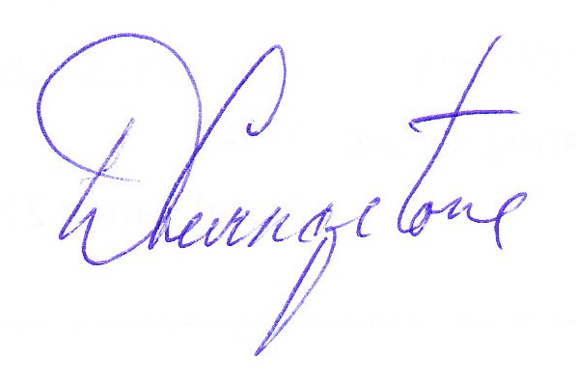
David Livingstone
Chair, Environmental Impact Screening Committee

Introduction
On June 5, 1984, the Committee for Original Peoples’ Entitlement (representing the Inuvialuit) and the Federal Government of Canada signed the Inuvialuit Final Agreement (IFA), which was subsequently legislated under the Western Arctic (Inuvialuit) Claims Settlement Act [S.C. 32-33 Elizabeth II C.24.]. Provisions of the IFA enable the Inuvialuit to participate and be meaningful partners in all decisions-making processes dealing with the management of the environment and wildlife within the Inuvialuit Settlement Region (ISR). Section 1 of the IFA expresses the following principles.
- To preserve the Inuvialuit cultural identity and values within a changing northern society.
- To enable the Inuvialuit to be equal and meaningful participants in the northern and national economy and society.
- To protect and preserve arctic wildlife, environment and biological productivity.

As one of five co-management groups established under the terms of the IFA, the EISC plays a vital role in achieving these goals through implementing the screening component of the IFA Environmental Impact Screening and Review Process.
The EISC’s mandate is to undertake a preliminary assessment of a proposed development and its environmental effects to determine whether a proposed development “…could have a significant negative environmental impact”. The EISC is not required to determine whether a proposed development “will” have a significant negative impact. Rather, the decision is whether it “could” have a significant negative environmental impact. This test of significance has a relatively low threshold, which is appropriate at a preliminary environmental screening stage. If the EISC determines that the proposed development “could” have a significant negative environmental effect then the proposed development will be referred to an environmental impact review process for further assessment and review. Further responsibilities of the EISC, as outlined in the IFA, can be found in Appendix B.
This Annual Activity report summarizes the EISC’s activities for the fiscal period of 1 April 2018 to 31 March 2019.

Membership
For the period of this report, the EISC has been without an appointed Canada Member. This position has remained vacant since March 17, 2017 when Mr. Rudy Cockney’s term ended. Mr. Albert Ruben Sr. did not seek reappointment as the Government of the Northwest Territories (GNWT) appointed member following his term end date of March 21st, 2019. The GNWT position is now also without an appointed member.
The following individuals comprised the EISC as of March 31, 2019;
Chair
David Livingstone Nominated by Canada. Appointed August 14, 2017
Yellowknife, NT Present Term: August 14, 2017 – August 13, 2020

Members

Ray Ruben Sr. Appointed by the Inuvialuit Game Council October 1, 2016
Paulatuk, NT Present Term: October 1, 2016 – September 30, 2019

Gerald Inglangasuk Appointed by the Inuvialuit Game Council October 1, 2015
Inuvik, NT Present Term: October 1, 2018 – September 30, 2021
Previous Term: October 1, 2015 – September 30, 2018
Previous Term: October 17, 2012 – September 30, 2015

Shannon O’Hara Appointed by the Inuvialuit Game Council October 1, 2016
Inuvik, NT Present Term: October 1, 2016 – September 30, 2019

Bengt Pettersson Nominated by the Government of Yukon. Appointed August 5, 2016
Whitehorse, YT Present Term: August 5, 2016 – August 4, 2019

Vacant Nominated by Canada

Vacant Nominated by the GNWT

Administrative and Technical Assistance
The EISC receives administrative, technical, and clerical support from the Joint Secretariat – Inuvialuit Settlement Region, Inuvik, NT. The EISC Coordinator serves as the Secretary to the EISC and provides full-time office support. Michel Lindsay is the EISC Coordinator. The EISC Coordinator position was fully staffed during the period of this report.
During the period of this report the EISC also received administrative support from various employees of the Joint Secretariat including: Mike Harlow, the former Executive Director; Jen Lam, Committee Program Manager; Arsalan Malik, Senior Administrative Officer; Cheryl Williams, Office Manager; Eunice Thrasher, Finance Officer; Shawna Kaglik, Travel/Accommodation Coordinators; and Bernice Joe, Secretary/Receptionist.
JoAnn P. Jamieson, of McLennan Ross LLP provided contractual legal services.

Committee Activities

Members attended screening meetings approximately every six weeks and participated in other activities on behalf of the EISC as required to fulfill the mandate of the EISC and to “expeditiously determine if the proposed development could have a significant negative environmental impact” as stated in section 11.(17) of the IFA.

Regular meetings
The EISC held seven of the regular meetings in Inuvik, NT: April 27, 2018, June 6-8, 2018, July 19, 2018, September 6, 2018, October 11, 2018, November 22, 2018, January 31, 2019, and March 13 and 15, 2019.
The EISC held one regular meeting via teleconference on December 20, 2018.
In addition to the regular EISC meetings, the Screening Committee held three special teleconferences on July 3, 2018, August 13, 2018, and February 23, 2019 to render decisions on files undergoing a full environmental impact screening. The Pre-screening Subcommittee (PSC) also met electronically as and when required to determine whether or not a project proposal required an environmental impact screening.

Submissions
It is the responsibility of the proponent to submit a project description to the EISC for environmental screening. Under IFA s 11.(36), “no license or approval shall be issued that would have the effect of permitting any proposed development to proceed unless the provisions of [IFA section 11(36)] have been complied with”. This requirement has the effect of requiring competent authorities to give notice of applications for licenses, permits or other authorizations to the EISC. These applications for proposed developments must be reviewed by the EISC to determine if they are subject to environmental impact screening.

A pre-screening decision as to whether a project proposal requires an environmental impact screening is made by a subcommittee, which consists of three of the seven EISC members. A panel of five EISC members makes Environmental Impact Screening decisions. The Panel consists of the Chair, two Inuvialuit members, a Canada member, and a territorial member nominated by the territory (YT or NT) within which the project is to occur. Decisions are made on a majority vote basis, with the Chair voting in the case of a tie.

Over the period of the 2018/2019 fiscal year, a total of eighty-three (83) projects were submitted to the EISC. Table 1 and Table 2 provide a breakdown of the projects submitted to the EISC over the 2018/2019 Fiscal Year.

EISC Project Submissions by Project Type
Category Type | Number of Submissions
Research | 39
Tourism | 20
Infrastructure-based | 8
Remediation | 3
Monitoring | 3
Decommissioning | 3
Geological Surveys | 2
Film | 2
Cruise Ship | 2
Military Exercise | 1
Total | 83
EISC Project Submissions by EISC Decision Type
EISC Decision Type | Number
Exempt | 60
Screened | 17
Undergoing Pre-Screening/Screening | 5
Requires additional information | 1
Referred to Review | 0
Total | 83

Table 2. The Project Submissions Received by the Environmental Impact Screening Committee Broken-down by Decision Type for the 2018/2019 Fiscal Year

Table 1. The Project Submissions Received by the Environmental Impact Screening Committee Broken-down Categorically for the 2018/2019 Fiscal Year

In 2018/2019, the EISC determined that it had both a mandate and an obligation to begin screening “other uses” on the Yukon North Slope. Thus far the EISC has considered three such proposals, one of which was considered exempt from screening. One project required a full environmental impact screening and one required further information before a preliminary decision could be made.
In addition to developments that are screened, the EISC asks to be informed of other projects proposed for the Inuvialuit Settlement Region that for various reasons may be exempt from the screening process. This enables the EISC to have a broad picture of the activities being carried out within the ISR for the purposes of cumulative impact assessment.
The EISC greatly appreciated the efforts of the other Joint Secretariat co-management groups, government agencies, Aurora Research Institute, and Inuvialuit Land Administration during the reporting year to keep the EISC apprised of such activities.
Appendix C: EISC Submissions includes a chart which summarizes the above screening activities.

Other Activities

Internal administrative projects were undertaken by the EISC during the 2018/2019 reporting period to fulfill section 11.(14) under the IFA, i.e., “The Screening Committee may establish and adopt by-laws and rules for its internal management and procedures in order to ensure reasonable and expeditious consideration of applications”.

EISC Arctic Marine Guidelines for the ISR
Inuvialuit Organizations and Co-Management Bodies met on June 25-27, 2018 in Inuvik to discuss issues and concerns with respect to marine shipping in the ISR. The EISC presented its draft ‘EISC Arctic Marine Guidelines for the ISR’ at the workshop. A similar guidance document was being developed by the Inuvialuit Regional Corporation. The workshop determined that the best approach moving forward would be for the IGC and IRC to lead the development of one IFA-wide guidance document which would incorporate the EISC draft.

EISC Exclusion List
The EISC Exclusion list has not been reviewed since its initial development in 2010. The EISC is currently reviewing the list to identify and remove ambiguities, to drop exclusion items that are no longer relevant, and to ensure transparent and consistent decision-making. The updated Exclusion list will be incorporated in the next revision of the EISC Guidelines, projected to be finalized by the end of 2020.

Environmental Impact Screening for the Yukon North Slope
The EISC has revised its Environmental Impact Screening process with respect to the Yukon North Slope. Pursuant to the IFA, the Yukon North Slope falls under a “special management regime whose dominant purpose is the conservation of wildlife, habitat, and traditional native use”. In order for the EISC to fulfill its mandate and to address concerns raised by Inuvialuit regarding research activities taking place on the Yukon North Slope, the EISC has begun considering “other uses” (section 12.3(b) of the IFA) on the Yukon North Slope to ensure that residents understand the nature of those activities and to ensure that there will be no significant negative impact on wildlife, habitat or native harvesting. On November 9th, 2018, the EISC notified stakeholders in writing of the change in process.

EISC Guidelines and Rules of Procedure Review
The EISC Guidelines require the Screening Committee to review the Screening Guidelines and Rules of Procedure at least every five years in order to maintain procedural consistency, fairness and transparency in its processes. The last comprehensive review took place in 2013/2014. The review has been initiated and will likely take several months to complete.
Presentations and Guests
The EISC routinely accepts presentations from proponents, particularly when the proposal is potentially controversial or complex. Other guests are invited to speak on topics of mutual interest. The following summarizes the presentations and guests received during 2018/2019.
July 12-14, 2017
- Aurora Research Institute – Scientific Services
Mr. Jonathan Michel & Ms. Nichole Hammer

January 31st, 2019
- Aurora Research Institute
Ms. Celtie Ferguson & Mr. Garfield Giff

Other Meetings Attended by the Environmental Impact Screening Committee Members or Appointed Representatives
During the fiscal year, the Chair, Members, and Coordinator attended other meetings related to their duties and the work of the EISC. These include the meetings, conferences, and workshops listed below.
April 2018
- Joint Secretariat Board Meeting (Vancouver, BC) – April 24-25, 2018 – David Livingstone

June 2018
- ISR Shipping Coordination Workshop (Inuvik, NT) – June 25-27, 2018 – David Livingstone & Michel Lindsay

July 2018
- Joint Secretariat Board Meeting (Teleconference) – July 10-11, 2018 – David Livingstone
- Boreal Caribou Range Planning Framework (Yellowknife, NT) – July 24-25, 2018 – Michel Lindsay

August 2018
- Inuvialuit Game Council (Whitehorse, YT) – August 30-31, 2018 – Bengt Pettersson

September 2018
- Proactive Vessel Management Workshop (Gatineau, QC) – September 18-19, 2018 – David Livingstone
- NWT Board Forum (Yellowknife, NT) – September 18-19, 2018 - Shannon O’Hara
- Pan-Territorial Board Forum (Yellowknife, NT) – September 24-27, 2018 – David Livingstone

November 2018
- Prairie & Northern Region – Canadian Marine Advisory Council (Yellowknife, NT) November 27-28, 2018 – Michel Lindsay

December 2018
- Inuvialuit Game Council Meeting (Inuvik, NT) – December 5-6, 2018 – Michel Lindsay
- Arctic Change Conference (Ottawa, ON) – December 10-14, 2018 – David Livingstone, Ray Ruben Sr., and Michel Lindsay.

January 2019
- Joint Secretariat Board Meeting (Inuvik, NT) – January 29, 2019 – David Livingstone

February 2019
- Inuvialuit Water Board – Water & Waste Management Workshop (Inuvik, NT) – February 6-7, 2019 – David Livingstone & Michel Lindsay

March 2019
- Inuvialuit Game Council Meeting (Inuvik, NT) – March 6-8, 2019 – David Livingstone & Michel Lindsay

Funding
Funding of all renewable resource-related activities associated with the implementation of the IFA is provided by Canada and coordinated by CIRNAC. Funding in 2018/2019 represented the second year in a new 10-year funding commitment.
The overall process of the funding agreement is coordinated by CIRNA, while the Joint Secretariat is responsible for overseeing the budget forecasts for the block submission to the Treasury Board. The resulting allocations for the EISC become part of the committee’s annual budget. The funds received under the contribution agreement between CIRNA and the Joint Secretariat support operational activities of the Committee. These costs, which include Chair costs and salary, Canada member costs and salary, and operational costs for the Committee’s Coordinator (secretary), are detailed in appendix D.

Summary
The 2018/2019 fiscal year was busy one for the EISC. In addition to screening over 80 proposals, the EISC undertook a number of administrative changes and attended several meetings, conferences and workshops related to its mandate. It will continue to focus on ensuring it meets its core mandate as set out in the IFA in as effective and efficient a manner as possible.

Appendix A: EISC Responsibilities under the IFA
As described in the Inuvialuit Final Agreement, The Environmental Impact Screening Committee shall, among its other activities:

Section 11.(1) The developments subject to environmental impact screening include:
(a) developments described in subsection 13(7);
(b) developments in the Yukon North Slope region described in section 12;
(c) developments in the Inuvialuit Settlement Region in respect of which the Inuvialuit request environmental impact screening; and
(d) subject to any agreement between the Inuvialuit and the Dene/Metis, developments in areas including the Aklavik land selections where the traditional harvest of the Dene/Metis may be adversely affected, on request by the Dene/Metis or by the Inuvialuit

Section 11.(14) The Screening Committee may establish and adopt by-laws and rules for its internal management and procedures in order to ensure reasonable and expeditious consideration of applications.

Section 11.(15) A register shall be kept of all decisions of the Screening Committee and the decisions shall be made available to the public on request.

Section 11.(17) On receipt of a project description, the Screening Committee shall expeditiously determine if the proposed development could have a significant negative environmental impact and shall indicate in writing to the governmental authority competent to authorize the development that, in its view:
(a) the development will have no such significant negative impact and may proceed without environmental impact assessment and review under this Agreement;
(b) the development, if authorized subject to environmental terms and conditions recommended by the Screening Committee, will have no such significant negative impact and may proceed without environmental impact assessment and review under this Agreement.
(c) the development could have significant negative impact and is subject to assessment and review under this Agreement; or
(d) the development proposal has deficiencies of a nature that warrant a termination of its consideration and the submission of another project description.

Section 11.(36) No licence or approval shall be issued that would have the effect of permitting any proposed development to proceed unless the provisions of this section have been complied with.

Appendix B: Financial Summary for Year Ending 31 March 2019
The Following pages present unaudited financial summaries for information purposes and should not be considered as definitive statements of account. For full financial details, the audited financial statements of the Joint Secretariat should be consulted. For further information, contact:

Office Manager
Joint Secretariat-Inuvialuit Settlement Region
Box 2120, Inuvik, NT X0E 0T0
Phone: (867) 777-2828
Fax: (867) 777-2610
Email: officemgr@jointsec.nt.ca

Revenue
AANDC Contribution (Implementation Funding) |  | $199,078.00
Chairs Expenses |  |  | $79,174.21
Other |  |  | $18,534.36
Services |  |  | $34,467.50
Canada Member |  |  | $0.00
Total Expenditures |  | $132,176.07
Excess Revenue (Expenditure) |  |  | $66,901.93
Revenue
GNWT – Environment & Natural Resources Contribution |  | $126,349.00
Inuvialuit Expenses |  |  | $41,386.63
Total Expenditures |  | $41,386.63
Excess Revenue (Expenditure) |  |  | $88,697.69
Revenue
AANDC Contribution (Implementation Funding) |  | $208,595.02
Staffing |  |  | $95,545.98
Overhead |  |  | $18,455.95
Other |  |  | $24,676.72
Community Tour |  |  | 3,826.18
Total Expenditures |  | $142,504.83
Excess Revenue (Expenditure) |  |  | $66,090.19

Appendix D: Submissions to the EISC 2018-2019 Fiscal Year
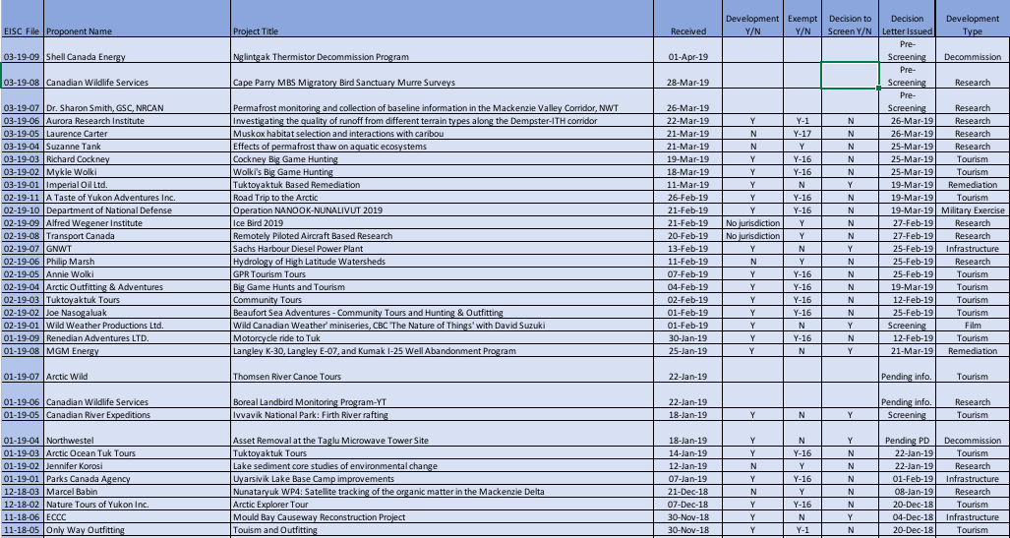
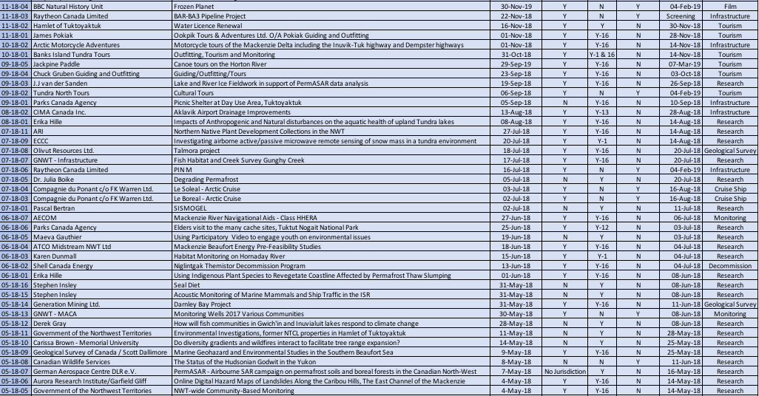

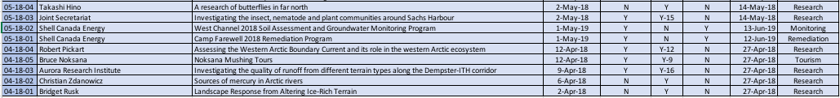

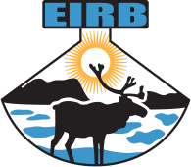

Environmental Impact Review Board
Annual Activity Report

Foreword from the Chair
The Inuvialuit Final Agreement established the Environmental Impact Review Board to carry out environmental impact reviews on developments which could have a significant negative environmental impact or a significant negative impact on wildlife harvesting in the Inuvialuit Settlement Region. The Environmental Impact Review Board and other renewable resource co-management bodies established by the Inuvialuit Final Agreement collaborate in the environmental management of the Inuvialuit Settlement Region.
It was my pleasure to Chair the Environmental Impact Review Board in 2018-19. During the Past Year the Board did not conduct any reviews, however the Board did take opportunities to expand its knowledge base on environmental impact assessments. The Board’s activities included addressing administrative matters, ongoing training of members and, as required, public outreach and education in respect of the system of Environmental Impact Assessment set out in the Inuvialuit Final Agreement.
The Board ran in full capacity in the Past Year and remains prepared to address any referrals which might result from screenings in 2019-2020.
This report provides a summary of the Board’s activities for the fiscal year commencing April 2018 and concluding March 2019.
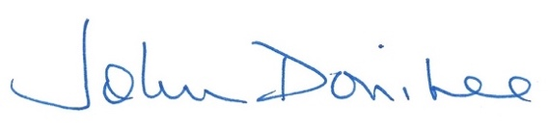
John Donihee, Chair
Environmental Impact Review Board

Introduction
The Environmental Impact Review Board (EIRB) is established under the terms of the Inuvialuit Final Agreement (IFA) between Canada and the Committee for Original Peoples Entitlement (COPE), representing the Inuvialuit. The IFA was approved, given effect, and declared valid by the Western Arctic (Inuvialuit) Claims Settlement Act [S.C. 32-33 Elizabeth II, C.24.] on June 28, 1984.
The IFA provides the framework for a two-stage Environmental Screening and Review Process that is carried out by the Environmental Impact Screening Committee (EISC) and EIRB [IFA Section 11.0]. The EISC conducts environmental screenings of development activities proposed for the Inuvialuit Settlement Region (ISR). The EIRB carries out detailed environmental impact assessments and public reviews of development projects referred to it by the EISC pursuant to the IFA.
Historically, the mandate of the Board also included the responsibility to set criteria for acceptable environmental standards for the Husky Lakes area. See section 8 of the IFA. Appendix E is a map of portions of the Husky Lakes area to which section 8 applies.
The Board’s mandate is thus set out in section 8(1) and section 11(22)-(37) and section 13(7)-(12) of the IFA. This mandate is exercised in support of the goals of the IFA as set out below. Provisions of sections 8, 11 and 13 of the IFA relevant to the EIRB mandate are found below in Appendices B, C and D.

Goals of the Inuvialuit Final Agreement
- To preserve Inuvialuit cultural identity and values within a changing northern society;
- To enable Inuvialuit to be equal and meaningful participants in the northern and national economy and society; and
- To protect and preserve the Arctic wildlife, environment, and biological productivity.

Board Members
The Environmental Impact Review Board (EIRB) consists of seven (7) permanent members, three (3) appointed by Canada, three (3) appointed by the Inuvialuit and a Chairman appointed by Canada, with the consent of the Inuvialuit. Of the three (3) appointed by Canada, each of the Governments of the Northwest Territories and the Yukon shall designate one (1).
Each member is appointed for a three-year term and are eligible for re-appointment.

Chair
John Donihee of Kingston, ON
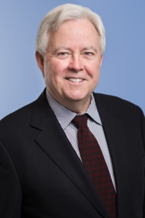
Nominated and appointed by the Government of Canada
Consent given from the Inuvialuit Game Council
Present Term: January 18th, 2018 to January 17th, 2021

Members
Catherine Cockney of Inuvik, NT
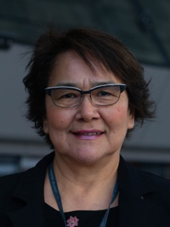
Nominated by the Government of the Northwest Territories
Appointed by the Government of Canada
Present Term: October 31st, 2016 to October 30th, 2019
Previous Terms: Member since December 2006

Crystal Lennie of Inuvik, NT
(Photo not available)
Appointed by the Inuvialuit Game Council
Present Term: October 1st, 2016 to September 30th, 2019
Previous Terms: Member since November 2013

Ethel-Jean Gruben of Inuvik, NT
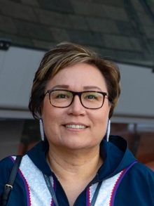
Appointed by the Inuvialuit Game Council
Present Term: October 1st, 2018 to September 30th, 2021
Previous Terms: Member since July 2015

Ian Robertson of Whitehorse, YT
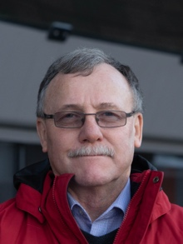
Nominated by the Yukon Government
Appointed by the Government of Canada
Present Term: February 8th, 2018 to February 7th, 2021

Jim Umpherson of Yellowknife, NT
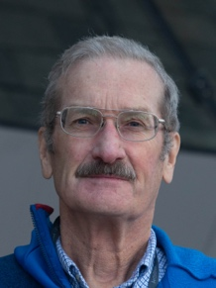
Nominated and appointed by the Government of Canada
Present Term: March 2nd, 2018 to March 1st, 2021
Previous Terms: Member since 2011

Roland Kikoak of Tuktoyaktuk, NT
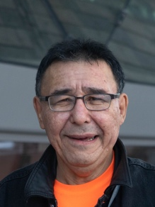
Appointed by the Inuvialuit Game Council
Present Term: September 22nd, 2017 to September 30th, 2020
Previous Terms: Member since September 2014

Board Activities

Meetings
June 22nd, 2018
JS Boardroom – Teleconference – Inuvik, NT
Chair: John Donihee
Participants: Catherine Cockney, Crystal Lennie, Ethel-Jean Gruben, Ian Robertson, Jim Umpherson, Roland Kikoak and Lenora McLeod

August 28th – 29th, 2018
Kwanlin Dunn Culture Centre – In-Person Meeting – Whitehorse, YT
Chair: John Donihee
Participants: Catherine Cockney, Ethel-Jean Gruben, Ian Robertson, Jim Umpherson, Roland Kikoak and Lenora McLeod

November 11th, 2018
JS Boardroom – Teleconference – Inuvik, NT
Chair: John Donihee
Participants: Catherine Cockney, Crystal Lennie, Ethel-Jean Gruben, Ian Robertson, Jim Umpherson and Lenora McLeod

December 12th, 2018
Novotel Conference Room – In-Person Meeting – Ottawa, ON
Chair: John Donihee
Participants: Catherine Cockney, Crystal Lennie, Ethel-Jean Gruben, Ian Robertson, Jim Umpherson, Roland Kikoak and Lenora McLeod

January 23rd, 2019
JS Boardroom – Teleconference – Inuvik, NT
Chair: John Donihee
Participants: Catherine Cockney, Crystal Lennie, Ian Robertson, Jim Umpherson, Roland Kikoak and Lenora McLeod

March 13th, 2019
IRC Boardroom – Teleconference – Inuvik, NT
Chair: John Donihee
Participants: Crystal Lennie, Ethel-Jean Gruben, Ian Robertson, Jim Umpherson and Lenora McLeod

Board Training and Development
April 15th – 20th, 2018
Microsoft Training – Inuvik, NT
Participants: Roland Kikoak

April 24th – 26th, 2018
Arctic Environmental Impact Assessment Workshop – Yellowknife, NT
Participants: Crystal Lennie and Jim Umpherson
EIRB made an informational presentation to the Arctic Council

June 22nd – 23rd, 2018
ISR Shipping Workshop – Inuvik, NT
Participants: John Donihee, Ian Robertson and Lenora McLeod

August 27th, 2018
MAC Computer training – Whitehorse, YT
Participants: John Donihee, Catherine Cockney, Ethel-Jean Gruben, Ian Robertson, Jim Umpherson, Roland Kikoak and Lenora McLeod

August 30th – 31st, 2018
IGC Meetings – Whitehorse, YT
Participants: John Donihee, Catherine Cockney, Ethel-Jean Gruben, Ian Robertson, Jim Umpherson, Roland Kikoak and Lenora McLeod
EIRB presented an update to IGC

September 18th – 19th, 2018
IAIA Decision Writing Workshop – Whitehorse, YT
Participants: Catherine Cockney and Ian Robertson

December 11th – 14th, 2018 Arctic Net – Ottawa, ON
Participants: John Donihee, Catherine Cockney, Crystal Lennie, Ethel-Jean Gruben, Ian Robertson, Jim Umpherson, Roland Kikoak and Lenora McLeod

March 13th – 14th, 2019 Arctic Oil and Gas Symposium – Calgary, AB
Participants: Roland Kikoak

March 27th – 28th, 2019 NWT Board Forum Training, Renewable Resources – Yellowknife, NT
Participants: Catherine Cockney, Ian Robertson and Lenora McLeod

Community Tour
The EIRB completed their first part of a community tour with EISC. Both co-management bodies presented the environmental assessment process that is relevant to the ISR that derives from the IFA. During the community tour, the members heard comments and concerns relating to the Inuvik-Tuk Highway that was open in 2017. The questions and concerns related to the social impacts that the Inuvik-Tuk highway has brought into the community of Tuk and how monitoring and enforcement of recommendations put forward by the EIRB is implemented.

Date | Location | Participants
March 12th, 2019 | Aklavik, NT | Crystal Lennie  Ian Robertson  Lenora McLeod
March 13th, 2019 | Inuvik, NT | Crystal Lennie,  Ethel-Jean Gruben  Ian Robertson  Lenora McLeod
March 14th, 2019 | Tuktoyaktuk | Crystal Lennie,  Ian Robertson  Lenora McLeod

Funding and Expenditures Summary
Funding for the Chair, Canada member, Yukon member, NWT member, Coordinator of the EIRB, and for project reviews conducted by the EIRB is provided by way of Contribution Agreements with Crown Indigenous Relations and Northern Affairs Canada (CIRNA).
Funding for the Inuvialuit members is provided by the way of a Contribution Agreement with the Government of the Northwest Territories.
Details of the funding and expenditures are set out in Appendix A below.

Summary
The 2018-2019 year has been seen an increase in tourism in the Western Arctic Region and EIRB members have taken part in workshops which will increase their knowledge on the potential effects of these activities should a tourism development project be referred by the EISC. The EIRB has also been keeping up-to-date with the ISR Shipping initiative, looking further into completing the Husky Lakes Criteria with input from the Inuvialuit Game Council and other co-management bodies and anticipating the introduction of the Federal Impact Assessment Act under Bill C-69. The EIRB completed the first part of their community tour this year, with EISC, and found the engagement with the communities to be successful and informative for all parties involved. The EIRB also received feedback on its process and how to effectively involve communities in review status. The EIRB continues to address its responsibilities under the IFA to the Inuvialuit, the Government of Canada, the Government of Northwest Territories and the Yukon Government.

Appendices

Appendix A
April 1st, 2018 to March 31st, 2019 Financial Summary

Appendix B
IFA Section 8 – Husky Lakes/Cape Bathurst Areas

8.(1) With respect to Area Number 2 as shown in Annex D, approval for any development activity shall be withheld unless the developer proves that the proposed development activity meets acceptable environmental standards and accounts for his standard of performance. The criteria for establishing acceptable environmental standards for the project and evaluating the developer's standard of performance shall be set by the Environmental Impact Review Board.
As amended by P.C. 1987-26, January 15, 1987

Appendix C
IFA Section 11 – Roles and Responsibilities
11.(22) The Environmental Impact Review Board is hereby established to be the review body for any development referred to it pursuant to this Agreement. The Review Board shall have seven (7) permanent members, three (q) appointed by Canada, three (3) appointed by the Inuvialuit and a Chairman appointed by Canada, with the consent of the Inuvialuit. Of the three (3) permanent members appointed by Canada, each of the Governments of the Northwest Territories and the Yukon shall designate one (1). The representation of the Government of Yukon Territory for matters north of the watershed and of the Government of the Northwest Territories for matters in the Western Arctic Region shall increase as their respective jurisdictions increase and shall form a majority of appointees for matters exclusively within their respective jurisdictions. The membership of the Review Board may be increased or decreased from time to time at the discretion of Canada, but the same proportion of representation for Canada and the natives shall be maintained.
As amended by P.C. 1987-26, January 15, 1987
11.(23) The Review Board shall deal with each development subject to environmental assessment and review in accordance with the applicable provisions of this Agreement. For greater certainty, subsections (9) to (12) apply to the constitution of the Review Board panels, with such modifications as the circumstances require.
As amended by P.C. 1987-26, January 15, 1987
11.(24) The permanent members of the Review Board shall be appointed, remunerated and replaced by the respective appointing parties. The term of office of all permanent members, including the Chairman, shall be three (3) years and they are eligible to be re-appointed on the expiration of the term.
11.(25) The remuneration required for the Inuvialuit members appointed to the Environmental Impact Review Board, referred to in subsection 11(24), and reasonable travel and accommodation costa, to attend regular meetings of the Review Board shall be reimbursed by the Government of the Northwest Territories, as provided through funding agreements between Canada and the Government of the Northwest Territories as are negotiated from time to time. These funding agreements shall not form part of the Agreement.
11.(26) Where any of the parties fails to nominate a sufficient number of persons within a reasonable time, the Review Board may discharge its responsibilities with such members as have been appointed.
As amended by P.C. 1987-26, January 15, 1987
11.(27) A person may be a member of both the Screening Committee and the Review Board.
11.(28) Canada shall provide to the Review Board the staff required to enable it to fulfil its functions. The Review Board may establish and adopt by-laws and rules for its internal management and its procedures.
11.(29) The Review Board shall expeditiously review all projects referred to it and on the basis of the evidence and information before it shall recommend whether or not the development should proceed and, if it should, on what terms and conditions, including mitigative and remedial measures. The Review Board may also recommend that the development should be subject to further assessment and review and, if so, the data or information required.
11.(30) Decisions of the Review Board shall be made by majority vote of the panel appointed, shall be in writing and shall be signed by all panel members.
11.(31) A register shall be kept of all decisions of the Review Board and the decisions shall be made available to the public on request.
11.(32) The decision containing the recommendations of the Review Board shall be transmitted to the governmental authority competent to authorize the development. That authority, consistent with the provisions of this section and after considering, among other factors, the recommendations of the Review Board, shall decide whether or not, on the basis of environmental impact considerations, the development should proceed and, if so, on what terms and conditions, including mitigative and remedial measures.
11.(33) If, pursuant to subsection (32), the competent governmental authority decides that further impact assessment and review is required, the proposed development shall be subject to further impact assessment and review based on the same or different information, requirements or specifications as the governmental authority considers appropriate.
11.(34) If the competent governmental authority is unwilling or unable to accept any recommendations of the Review Board or wishes to modify any such recommendations, it shall give reasons in writing within thirty (30) days, stating why it has not accepted the recommendations.
As amended by P.C. 1987-26, January 15, 1987
11.(35) The decision of the competent governmental authority shall be transmitted to the interested parties and made public.
11.(36) No licence or approval shall be issued that would have the effect of permitting any proposed development to proceed unless the provisions of this section have been complied with.
11.(37) For greater certainty, nothing in this section restricts the power or obligation of the Government to carry out environmental impact assessment and review under the laws and policies of Canada.

Appendix D
IFA Section 13 – Wildlife Impact Assessment
13.(7) Every proposed development of consequence to the Inuvialuit Settlement Region that is likely to cause a negative environmental impact shall be screened by the Screening Committee to determine whether the development could have a significant negative impact on present or future wildlife harvesting.
13.(8) If the Screening Committee determines that a proposed development could have a significant negative impact on present or future wildlife harvesting, it shall refer the proposal for an environmental impact assessment and review in the manner provided by subsections (9) and (10).
13.(9) Where a proposed development is subject to environmental impact review that, in the opinion of the Screening Committee, adequately encompasses or will encompass the assessment and review function and includes or will include in its evaluation adequate terms and conditions of development and limits of liability, the Screening Committee shall refer the proposal to the body carrying out the environmental impact review.
13.(10) If, in the opinion of the Screening Committee, the review body does not or will not adequately incorporate within its review each element of the process set out in subsection (9), or if the review body declines to do so, the proposal shall be referred to the Review Board.
13.(11) Where, pursuant to subsection (10), a proposal is referred to the Review Board, it shall, on the basis of the evidence and information before it, recommend to the government authority empowered to approve the proposed development:
- terms and conditions relating to the mitigative and remedial measures that it considers necessary to minimize any negative impact on wildlife harvesting; and
- an estimate of the potential liability of the developer, determined on a worst-case scenario, taking into consideration the balance between economic factors, including the ability of the developer to pay, and environmental factors.

13.(12) The Government agrees that every proposed development of consequence to the Inuvialuit Settlement Region that is within its jurisdiction and that could have a significant negative impact on wildlife habitat or on present or future wildlife harvesting will be authorized only after due scrutiny of and attention to all environmental concerns and subject to reasonable mitigative and remedial provisions being imposed.

Appendix E
Cape Bathurst/Husky Lakes Annex D
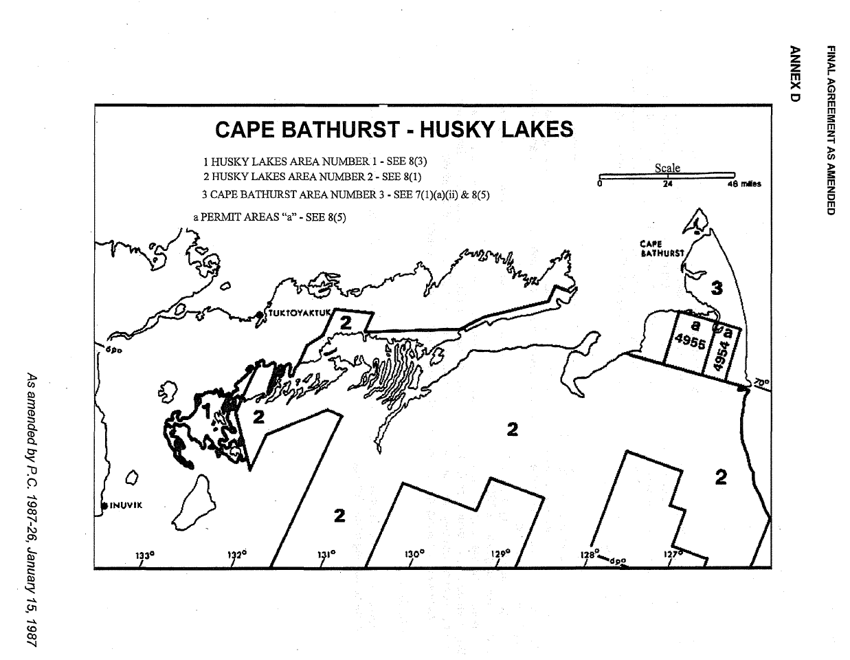

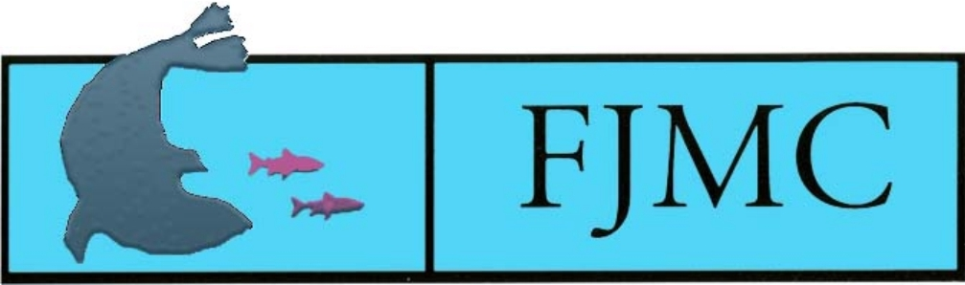

Fisheries Joint Management Committee
Annual Activity Report

Foreword
The Inuvialuit Final Agreement sets out the terms of the contract between the Committee for Original Peoples’ Entitlement, representing the Inuvialuit of the Inuvialuit Settlement Region, and the Government of Canada, representing all citizens of Canada.
As outlined in that Agreement, the Fisheries Joint Management Committee was established to provide advice to the Inuvialuit and Fisheries and Oceans Canada (DFO) on fishery management and related issues within the Inuvialuit Settlement Region. During the reporting year, the Fisheries Joint Management Committee continued to work closely with government agencies, renewable resource user groups, and resource councils and committees established under the Agreement and by other land claim settlements on a variety of activities and programs. This report provides a summary of the committee’s activities for the fiscal year commencing April 2017 and concluding March 2018.

Introduction
Canada’s Minister of the Department of Fisheries and Oceans (DFO) established the Fisheries Joint Management Committee (FJMC) in 1986, pursuant to the Inuvialuit Final Agreement (IFA) of 1984. The FJMC has the following responsibilities: (1) to assist Canada and the Inuvialuit in administering the rights and obligations related to fisheries under the IFA, (2) to assist the Minister in carrying out his responsibilities for the management of fisheries and marine mammals in the Inuvialuit Settlement Region (ISR), and (3) to advise the Minister on all matters relating to Inuvialuit and ISR fisheries. The specific responsibilities of the FJMC are provided in Appendix A. The committee maintains an office at the Joint Secretariat in Inuvik and employs resource specialists to manage its programs.

Membership

Chairman
David Victor Gillman (retired Chairman)
Dr. Alan Kennedy (effective September 2018)

Members
Dr. George Burton Ayles – Canada Member
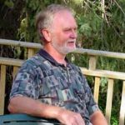
Brian Zytaruk – Canada Member
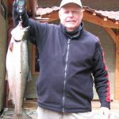
Gerald Inglangasuk – Inuvialuit Member
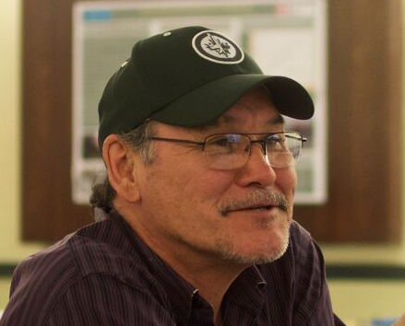
John Noksana Jr. – Inuvialuit Member
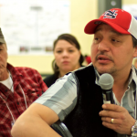

Inuvialuit Alternate Members
Charles Pokiak (resigned February 2018)
Joshua Oliktoak (2017 to present) – Inuvialuit Alternate Member, Ulukhaktok, NT
Richard Binder (2017 to present) – Inuvialuit Alternate Member, Inuvik NT

Resource Specialists
Vanessa Cunningham (resigned March 2019)
Emily Way-Nee
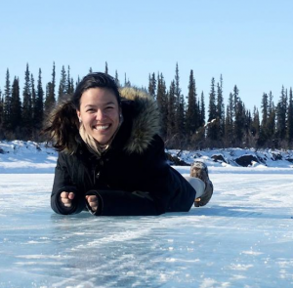

Members and Staff Update
Vic Gillman retired as FJMC Chairman, and Alan Kennedy is the new Chairman of the FJMC, effective September 2018. Gerald Inglangasuk and John Noksana Jr. are the Inuvialuit representatives on the FJMC appointed by the Inuvialuit Game Council, and Burton Ayles and Brian Zytaruk are the Canada appointed members to the FJMC. Vanessa Cunningham gave her notice of resignation on March 11, 2019. Emily Way-Nee continues as the FJMC resource coordinator, and a replacement for Vanessa Cunningham is in progress.

Committee Activities
Four regular FJMC meetings were held between April 1, 2018 and March 31, 2019. The FJMC met in Edmonton from April 4-6, 2018 to allocate operations and programs funding for the 2018-2019 fiscal year, and confirm IFA Implementation, TNMPA, and ANMPA funding to DFO research programs after full proposals were reviewed, as well as other regular business. The FJMC Community Tour meetings were h held between June 13-19, 2018 and included meetings with the Hunters & Trappers Committees (HTCs) in Sachs Harbour, Ulukhaktok, Paulatuk, and Aklavik to discuss local concerns and priorities for fish and marine mammals. The June meeting also included regular business items as well as interviews for the new FJMC Chairman position. The FJMC met in Inuvik from September 18-21, 2018, and this session included a one-day meeting with the Presidents (or their appointed alternate) of the Inuvialuit HTCs. This meeting provided the opportunity for the HTC President representatives to discuss their concerns related to fish and marine mammals in-camera, before providing a report to the FJMC and DFO representatives on their ISR-wide and community priorities. The FJMC summarized the feedback received from the HTCs throughout the year to update their annual priority list, which was shared with DFO and other researchers, and is used to determine which project proposals should be funded for the upcoming fiscal year. The FJMC met in Winnipeg from January 14-18th, 2019 to review submitted DFO research proposals and allocate research funding. This meeting was also an opportunity for researchers to report back to FJMC on their 2018-2019 project results.

Integrated Oceans Management

Gerald Inglangasuk, FJMC Inuvialuit Member, remains a member of the Western Arctic Marine Protected Areas (WAMPA) Steering Committee, along with DFO and Inuvialuit representatives from the Mackenzie Delta and Paulatuk. Additionally, two MPA Working Groups have been established to make decisions specific to each MPA. The first state of the TNMPA report is in its final stages, lead by DFO with support from co-management groups, to examine the success of the TNMPA monitoring indicators. The monitoring and management plans for the ANMPA are also being developed. Kayla Hansen-Craik was hired by the Joint Secretariat as the ISR MPA Coordinator; Kayla is working closely with DFO, the FJMC and other co-management partners to improve regional capacity for the management of MPAs. Several new and ongoing research projects have been approved by the FJMC and the respective MPA Working Groups for the 2019-2020 fiscal year. These projects will assist in better understanding the MPAs and be used to develop effective monitoring and management plans for the MPAs.

Fisheries and Marine Mammal Management

The Dolly Varden Integrated Fisheries Management Plan (DV IFMP) Steering Committee consists of managerial representatives from the FJMC (Alan Kennedy), Gwich’in Renewable Resources Board (GRRB), DFO, and Parks Canada. The DV IFMP Steering Committee, along with the West Side Working Group (WSWG) and Rat River Working Group (RRWG), are responsible for the continued implementation of the IFMP that was signed in November 2010. The RRWG met in Inuvik on March 4th, 2019 and the WSWG met in Aklavik on March 5th, 2019. At these meetings, ongoing research and char population studies were discussed. From 2014 to 2019, the WSWG recommended that a small-scale harvest of Dolly Varden could be undertaken at the Big Fish River Fish Hole (approved through a DFO Aboriginal Communal Fishing Licence), where a regulatory closure of all Dolly Varden harvests has been in place since 1987. Following the SARA listing of the northern form of Dolly Varden as a ‘Species of Special Concern’, the FJMC and other co-management partners are currently in the final stages of updating the DV IFMP to meet the requirements of a SARA plan for this species, while maintaining the regional co-management structures that have been effective and are supported by communities.

The Paulatuk Char Working Group (PCWG) and the Ulukhaktok Char Working Group (UCWG) are composed of Hunters and Trappers Committee members, DFO, Parks Canada, and FJMC and they met for their annual meeting in Paulatuk on February 19th, 2019, and Ulukhaktok on February 18th, 2019, respectively. At these meetings, they discussed ongoing research and monitoring in their respective areas. They also discussed the voluntary char harvest numbers for the community harvest. Paulatuk and Ulukhaktok both have Char Management Plans that are in the process of being updated.

For the Inuvik-Tuktoyaktuk Highway (ITH), which officially opened on November 15, 2017, the FJMC finalized a community fishing plan for the area based on directions and feedback from Inuvialuit from Inuvik and Tuktoyaktuk, with support provided by the FJMC and DFO. In order to communicate and promote this fishing plan, the FJMC has developed the Imaryuk Monitoring Program which hires two junior monitors and a senior monitor from both Inuvik and Tuktoyaktuk to patrol the highway. The monitors provide information on the new community fishing plan and report on harvest numbers and location.

Emily Way-Nee managed the 2018 Fish and Marine Mammal Community Monitoring Program (FMMCMP) for the FJMC. Monitors were hired and trained in the communities of Inuvik, Tuktoyaktuk, Paulatuk and Ulukhaktok (on-call), and a harvester reward program is available for hunters to sample their own whales in the communities of Aklavik and Sachs Harbour, as well as the other 4 ISR communities when there is no beluga monitor on contract.

Other
The FJMC attended Arctic Net in Ottawa, December 2018. At this meeting, the committee organized a workshop with the other Arctic marine co-management boards to discuss key issues and concerns in each region and work collaboratively on shared issues moving forward. Additionally, the FJMC met with Minister Wilkinson (Minister of Canadian Coast Guard and Fisheries and Oceans Canada) in December 2018, to update and discuss issues of success and concern in the ISR, as well as the newly announced Arctic Region. Additionally, Gerald Inglangasuk and the FJMC resource staff met with the new Arctic Region Regional Director General, Gabriel Nirlungnayuq on February 6th, 2019 in Inuvik to further discuss the new DFO and CCG Arctic Region.

Funding
Funding of all renewable-resource-related activities associated with the implementation of the IFA is provided by Canada and coordinated by CIRNA. Until the current year, funding has been allocated in 5-year blocks, with 2017/2018 representing a 10-year funding commitment. The funding renewal process has been completed, and renewed implementation funds were provided in February 2018. Due to the lateness of the funding, few program changes were implemented at this time. Workplans will be adjusted in the coming year to account for the increased funding.
Currently, the CIRNA IFA funding is provided to the Board of the Joint Secretariat, which then allocates funds to the individual resource committees. These FJMC provide funds to the Joint Secretariat for FJMC programs as needed. The resulting allocations for the FJMC become part of the committee’s annual operating budget. A portion of the funds are categorized as Operations and Programs. The operational activities of the committee, as well as some specific programs identified by the FJMC, are funded through this contribution agreement between CIRNA and the Joint Secretariat. These costs, which are subject to an annual audit, include Inuvialuit participation costs, Chair costs, and salary and operational costs for the committee’s resource specialists.
A second funding mechanism also supports the research activities of the FJMC. These funds are applied for through the DFO under a contribution agreement to support implementation costs for the identification and understanding of fisheries stocks and harvests in the ISR. For those activities described as research and monitoring, the projects and their budgets are identified by the FJMC, while the funds to support the projects are administered by DFO. This arrangement is efficient since, for the most part, the projects are carried out by DFO staff. As a result of the MPA additions since 2013, DFO has also provided Oceans Management contribution agreements dedicated to research and monitoring projects associated with MPAs. In January 2018, the funds received were assigned to project work for 201 and, through arrangements with DFO and CIRNA, the support costs for FJMC Canada members were provided under these contribution agreements. These arrangements have proven efficient and cost effective for all concerned and are expected to continue in the future.

Summary
The 2017/2018 year has been a very busy and constructive year for the FJMC. As more activities are tackled, a significant leadership role has been undertaken by individual members of the committee and much has been accomplished on committee responsibilities. Significant progress has been achieved on the Imaryuk Monitoring Program, ISR-wide Guardians concept paper, Beluga tagging program, and the refocusing of the ISR CBMP toward the collection of Inuvialuit harvest data. The IOMP is being implemented through the creation of a second MPA in the western Arctic and the consideration of additional oceans programming initiatives and federal targets for increased conservation areas in Canada. The Beluga Management Plan tourism guidelines continue to be updated; finalization of the updated plan and the implementation of tourism guidelines will happen in the coming year. An active and focused research program was conducted, with good results communicated back. The committee continues to address its responsibilities under the IFA to the Inuvialuit and to the Government of Canada.

Appendix A. FJMC Responsibilities
As described under Section 14(64) of the Inuvialuit Final Agreement, the Fisheries Joint Management Committee shall, among its other activities:
(a) review information on the state of fishing in waters on 7(1)(a) and 7(1)(b) lands and Crown lands in any areas where the Inuvialuit have an interest and fishery related activities on 7(l)(a) and 7(1)(b) lands;
(b) identify areas of waters on 7(1)(a) and 7(1)(b) lands where fishing has taken place and predict where fishing may in the future take place;
(c) determine current harvest levels;
(d) develop, maintain and control a public registration system for fishing in waters on 7(1)(a) and 7(1)(b) lands and for entry on 7(1)(b) lands for the purpose of fishing;
(e) restrict and regulate the public right to enter on 7(1)(b) lands for the purpose of fishing where such restriction and regulation is required for the conservation of a stock, to prevent serious conflict with Inuvialuit activities, to prevent interference with other Inuvialuit use of the land to which they have title or to prevent unreasonable interference with Inuvialuit use and enjoyment of the land;
(f) deny entry to persons who abuse the right;
(g) allocate subsistence quotas among communities;
(h) determine the reporting requirements and review the role of “the Hunters and Trappers Committees” in regulating the subsistence harvest and collection of harvest statistics;
(i) make recommendations to the Minister of Fisheries and Oceans on subsistence quotas for fish, harvestable quotas for marine mammals, Inuvialuit commercial fishing, allocation of the preferential fishing licences to be granted under subsections (29) to (32), regulations regarding sport and commercial fishing in waters on 7(1)(a) and (b) lands and the identification of waters where such fishing may be prohibited; and
(j) advise the Minister of Fisheries and Oceans on regulations, research policies and administration of fisheries generally affecting the Inuvialuit Settlement Region, and on any new international agreements being developed that might apply to Inuvialuit fisheries.

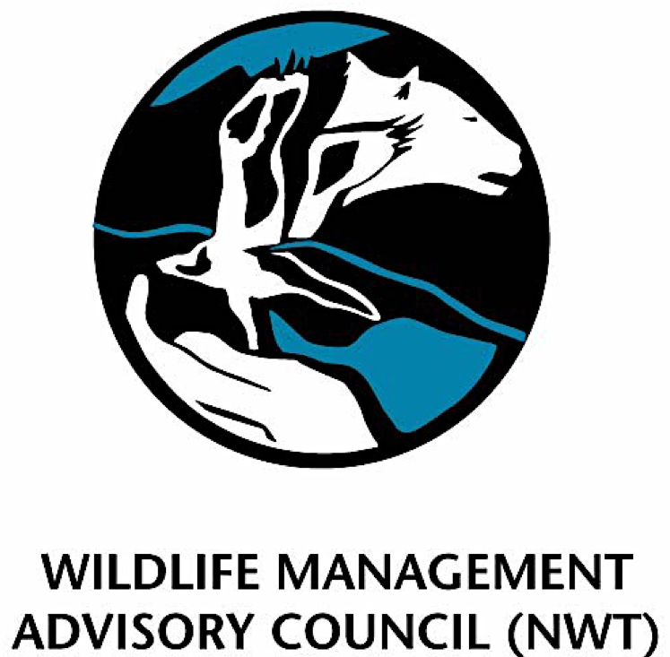
Annual Activity Report

Foreword
In 2018/19, the Wildlife Management Advisory Council (NWT) (the Council) continued to implement its business processes under the Inuvialuit Final Agreement. The Council was created under the Inuvialuit Final Agreement (IFA), to give effect to the principles of co-management of wildlife by Inuvialuit and governments, as specified in the IFA Section 14.

Introduction
The Council was created under the Inuvialuit Final Agreement (IFA), to give effect to the principles of co-management of wildlife by Inuvialuit and governments, as specified in the IFA Section 14. The Council began its first full year of activities in 1987/88. This thirtieth annual report describes the activities of the Council during fiscal year 2017/2018 (April 1, 2017 to March 31, 2018).
The Council’s mandate is to advise appropriate government agencies, the Inuvialuit Game Council, Hunters’ and Trappers’ Committees and other co-management boards or councils on policy, legislation, regulation and administration respecting wildlife, habitat, harvesting, conservation, research and management in the Western Arctic Region within the Inuvialuit Settlement Region. For the purpose of these procedures, the Western Arctic Region is that portion of the Inuvialuit Settlement Region which falls within the Northwest Territories.

Council Membership and Meeting Summary
The Council’s membership consists of three members appointed by the Inuvialuit Game Council (IGC), two members appointed by the Government of the Northwest Territories (GNWT), one member appointed by the Government of Canada, and a Chair. The Chair is appointed by the Government of the Northwest Territories, with the consent of the Inuvialuit and Canada.
The Council focuses on the conservation of terrestrial wildlife species (including polar bears), and birds. For that reason, the Northwest Territories appoints representatives from the Department of Environment and Natural Resources (ENR), and Canada appoints a representative from the Canadian Wildlife Service (CWS).
Staff and Membership Summary for 2018/2019:
Staff
Jodie Maring | Resource Coordinator | Since September 2016
Rosemin Nathoo | Wildlife Biologist | Since November 2018
Allison Thompson | Wildlife Biologist | January 2017 – October 2018
Chair
Larry Carpenter |  | Re-appointed August 2016, expires August 2021
Government Members
Rob Gau | ENR Headquarters, GNWT | Appointed September 2008, indeterminate period
Marsha Branigan | ENR Inuvik Region, GNWT | Appointed March 2008 for an indeterminate period
Eric Reed | Canadian Wildlife Service, Environment and Climate Change Canada | Appointed May 2015 for an indeterminate period
Government Alternate Members
Joanna Wilson | ENR Headquarter, Government of the Northwest Territories | Appointed April 2013 for an indeterminate period
Norman Snowshoe | ENR Inuvik Region, Government of the Northwest Territories | Appointed August 2017 for an indeterminate period
Marie Fast | Canadian Wildlife Service, Environment and Climate Change Canada | Appointed May 2017 for an indeterminate period
Inuvialuit Members
Bradley Carpenter |  | Re-appointed September 2018, expires September 2021
Dennis Arey |  | Appointed July 2018, expires September 2021
Jimmy Kalinek |  | Appointed October 2018, expires September 2020
Charles Pokiak |  | Re-appointed September 2016, terminated April 2018
Jody Illasiak |  | Appointed January 2018, terminated April 2018
Inuvialuit Alternate Members
Josh Oliktoak |  | Appointed January 2018, expires September 2019
Dang-Dang Gruben |  | Appointed October 2018, expires September 2020
Paul Voudrach |  | Appointed January 2019, expires September 2020
John Lucas Jr. |  | Appointed September 2016, expires September 2018
Deva-lynn Pokiak |  | Appointed January 2018, terminated April 2018

Council Activities
The Council activities for fiscal year 2017/2018 included:
- Meetings
- Community Conservation Plans
- By-law Development, Quotas, Seasons and Zones for Wildlife Harvesting
- Legislation Affecting Wildlife Management
- Research
- Other

Meetings
During the 2018/2019 fiscal year the Council met:
- June 13-15, 2018 – WMAC (NWT) meeting (Tuktoyaktuk, NT).
- August 25-27, 2018 – WMAC (NWT) meeting (Dawson, YT).
- November 28-30, 2018 – WMAC (NWT) meeting with alternates (Inuvik, NT).
- March 4-6, 2019 – WMAC (NWT) meeting (Inuvik, NT).

To enable the Council to adequately and knowledgeably fulfill its mandate, Council chair and members participated in the following meetings during the fiscal year.

A summary of meetings and committees of which WMAC (NWT) is a member:

Advisory Committee for Cooperation on Wildlife Management:
The ACCWM has a membership comprised of the chairs of the WMAC (NWT), Gwich’in Renewable Resources Board (GRRB), Sahtu Renewable Resources Board (SRRB), Kitikmeot Regional Wildlife Board (KRWB), Nunavut Wildlife Management Board (NWMB), and the Wek’èezhìi Renewable Resources Board (WRRB), as well as the Chair of the Tuktut Nogait National Park Management Board. The Bluenose Caribou Herds Management Cooperation Agreement, signed in March 2000, established the Committee. The roles of the Committee are to: oversee the implementation of a management plan; recommend a system for determining quota limitations; and share harvest information among regions where these herds range.
Some of the members from the management boards of ACCWM are appointed to two separate working groups: the ACCWM working group and the Communication and Education working group. These working groups have discussions through teleconferences, and if needed, a face-to-face meeting.
The Annual Status Meeting was November 20-22, 2018 in Yellowknife, NT with Larry Carpenter, Marsha Branigan, and Jodie Maring attending. Marsha Branigan, Allison Thompson and Jodie Maring participated in ACCWM working group and Communication and Educations working group teleconferences in 2018/2019.

Conference of Management Authorities
The Conference of Management Authorities (CMA) was established under the Species at Risk (NWT) Act. Membership of the Conference is comprised of wildlife co-management boards and governments that share management responsibility for the species at risk in the NWT.
The CMA held two face-to-face meetings and teleconferences. Rob Gau, Larry Carpenter, and Jodie Maring attended the face-to-face meeting on May 15-16, 2018 in Yellowknife, NT; Larry Carpenter, Rob Gau, Rosemin Nathoo, Chanda Turner, and Jodie Maring attended the face-to-face meeting from February 19-21, 2019 in Inuvik, NT. Rob Gau, Larry Carpenter, Allison Thompson, and Jodie Maring participated in the CMA teleconferences.
Species at Risk Committee
The Species at Risk Committee (SARC) was established under the Species at Risk (NWT) Act. The SARC members are appointed by the CMA members based on their knowledge of NWT plants and animals.
The SARC held one face-to-face meeting and one teleconference during 2018/2019. Allison Thompson attended the meeting from April 3-5, 2018 in Tulita, NT.

Wildlife Act meetings:
The Section 15 Wildlife Act is an annual meeting hosted by the GNWT Department of Environment and Natural Resources to promote cooperative and collaborative working relationships for effective wildlife management at the local, regional and territorial levels. Larry Carpenter and Bradley Carpenter attended this meeting held by ENR from October 23-24, 2018 in Yellowknife.
The Wildlife Act working group is comprised of GNWT, Indigenous governments and organizations, and renewable resources boards, tasked to review current NWT Wildlife Act and regulations, review proposed new regulations and other documentation, and provide comments in a collaborative forum. Larry Carpenter and Bradley Carpenter attended the working group meeting from October 25-26, 2018 in Yellowknife, NT.
Polar Bear Administrative Committee
The Polar Bear Administrative Committee (PBAC) is comprised of federal government representatives and representatives from Ontario, Quebec, Newfoundland and Labrador, Manitoba, Nunavut, Yukon and the Northwest Territories. The PBAC provides a forum for the collaborative management of polar bear populations by relevant jurisdictions in Canada to ensure that Canada fulfils all obligations for polar bear conservation, including obligations under the International Agreement on the Conservation of Polar Bears and Their Habitat.
Larry Carpenter participated in the face to face meeting on May 13-14, 2018 in Moose Jaw, SK and a teleconference on November 21, 2018.
Polar Bear Technical Committee
The PBAC established the Polar Bear Technical Committee (PBTC) in 1970 to provide support to PBAC by reviewing scientific research and Indigenous Traditional Knowledge and providing an annual status assessment of the polar bear subpopulations in Canada.
The representatives for PBTC are from each jurisdiction where polar bears are found (Manitoba, Newfoundland and Labrador, the Northwest Territories, Nunavut, Ontario, Québec and the Yukon).
Larry Carpenter, Allison Thompson, and Jodie Maring participated in the teleconference on November 28, 2018; Larry Carpenter and Rosemin Nathoo attended the meeting on February 5-7, 2019 in Edmonton, AB.
Inuvialuit Game Council Regular meetings
Larry Carpenter attended to the IGC meeting on June 22, 2018 in Tuktoyaktuk, NT; Larry Carpenter attended the IGC meeting on August 31, 2018 in Whitehorse, YT and on December 6, 2018 in Inuvik, NT; Larry Carpenter attended the IGC meeting on March 8, 2019 in Inuvik, NT.

Other meetings with WMAC (NWT) participation related to WMAC (NWT) business:
Inuvik-Tuktoyaktuk Highway Corridor Working Group meeting
Allison Thompson attended the meeting on May 14, 2018 in Inuvik, NT; Jodie Maring attended the meetings on November 14, 2018 in Inuvik, NT.
Beaver Management teleconferences
Larry Carpenter, Marsha Branigan and Jodie Maring attended the teleconference on October 17, 2018.
Inuvialuit/Inupiat Polar Bear Joint Commissioner’s meeting
Larry Carpenter attended the meeting from August 7-8, 2017 in Edmonton, AB.
WMAC (NWT and NS) Joint meeting
Allison Thompson, Marsha Branigan, Rob Gau, and Larry Carpenter attended the joint meeting on August 29, 2018 in Whitehorse, YT. Larry Carpenter, Rob Gau, Marsha Branigan, Dennis Arey, Rosemin Nathoo, and Jodie Maring attended the Joint WMACs meeting on November 30, 2018 in Inuvik, NT.
Species at Risk ISR Community Tour
Marsha Branigan, Larry Carpenter, Allison Thompson, and Jodie Maring held community meetings in Paulatuk, Aklavik, Inuvik, and Tuktoyaktuk between September 13 – October 2, 2018. Larry Carpenter, Marsha Branigan, and Jodie Maring held community meetings in Ulukhaktok on November 5, 2019 and in Sachs Harbour on November 7, 2019.
2018 Light Goose Management Workshop
Bradley Carpenter attended the workshop September 25-27, 2018 in Winnipeg, MB.
North American Caribou Workshop
Larry Carpenter, Dennis Arey, and Jimmy Kalinek attended the workshop October 29 – November 1, 2018 in Ottawa, ON.

Arctic Net Conference
Larry Carpenter, Jimmy Kalinek, and Jodie Maring attended the conference December 10-14, 2018 in Ottawa, ON.
Tuk Pen and Cape Bathurst Sensitive Habitat Working Group
IGC and WMAC (NWT) co-hosted the working group meetings with the AHTC, IHTC, THTC, and invited members from ENR, ECCC, and IRC. Jodie Maring and Rosemin Nathoo facilitated the meeting on January 23, 2019 in Tuktoyaktuk, NT. Rosemin Nathoo and Jodie Maring facilitated with IGC staff another meeting on March 27, 2019 in Inuvik, NT.
Dolphin and Union User to User Meetings
Larry Carpenter, Josh Oliktoak, Jodie Maring, and Rosemin Nathoo attended the Dolphin and Union User to User meeting on February 2-3, 2019 in Edmonton, AB. Rosemin Nathoo facilitated the DU community meeting in Ulukhaktok, NT on March 13, 2019 with the NWT user groups.
Inuit-Inuvialuit Polar Bear Commissioners (Northern Beaufort) Meeting
Larry Carpenter, Joshua Oliktoak, Rosemin Nathoo, and Jodie Maring attended the meeting on February 4, 2019 in Edmonton, AB.
Community Conservation Plans
The WMAC (NWT), pursuant to its responsibility for conservation and management plans under article 14(60)b of the Inuvialuit Final Agreement, takes the lead in the development and revision of the six Community Conservation Plans. A full revision of the CCPs commenced in November 2014 and completed April 2018.

Legislation Affecting Wildlife Management
All parties remain committed to the development, approval and enactment of HTC bylaws as regulations under the Wildlife Act. Up to March 31, 2018 there were several bylaws and regulations in development or in the process of being amended. The following is a brief summary:

Big Game Hunting Regulations: definition | - Conflicting definitions of “tag” occur in the Big Game Hunting Regulations and Wildlife Act.  - Big Game Hunting Regulations definition needs removal because the text is a carry-over from pre-November 2014 and conflicts with the new collaboratively developed definition of tag in the Wildlife Act.  - The definition of “tag” will be removed from the Big Game Hunting Regulations.
Big Game Hunting Regulations: schedule | The following errors of the Schedule in the Big Game Hunting Regulations are either human caused typographical errors or necessary corrections to address updated regulations:  - Schedule Part 5A (barren-ground caribou): Area I/BC/04 has been replaced by I/DU/04. Remove Item 20 and Item 21 in Schedule Part 5A as it has already been replaced by Schedule Part 5A.1 (Dolphin and Union Caribou)  - Schedule Part 11A (muskox): Item 30 has the season closing April 30. It must match the season closure in Items 20 and 25 as the season closes April 15  - Schedule Part 12 (wolf): Area I/WF/06 does not spatially exist. Remove I/WF/06 from Item 8, Item 13, Item 19  - Schedule Part 13 (wolverine): Item 6 incorrectly has a season close of October 10. It must match Item 11 where the season close is October 31
Licence & Permits Regulations | - Every permit required under the Wildlife Act is described in the Trapping Regulations, Wildlife Business Regulations, or the Wildlife Licences and Permits Regulations.  - Before the new Wildlife Act was enabled in November 2014 the permit for the interaction, manipulation or close observation, including the making of a film or the provision of an expedition, safari or cruise for big game species was covered under a Wildlife Research Permit. The Wildlife Act now specifically covers these activities in s.85 and is called a Wildlife Observation Permit.  - As Wildlife Observation Permits are new in the Act, it was an oversight that it was not added to the Wildlife Licences and Permits Regulations.

ISR related regulations: All regulations are following the MOU processes
Mandatory sample submissions for I/PC/01 | ENR supported the recommendation.  - At MOU stage 4, step 10: GNWT conducts the internal review necessary to expeditiously incorporate the bylaw into a regulation. A regulation is drafted, and a copy of the draft regulation is sent to the Joint Secretariat office of the WMAC (NWT).
creation of I/DU/05, no tag, no season requirement | ENR supported the recommendation.  - At MOU stage 4, step 10: GNWT conducts the internal review necessary to expeditiously incorporate the bylaw into a regulation. A regulation is drafted, and a copy of the draft regulation is sent to the Joint Secretariat office of the WMAC (NWT).
Season modification for I/BC/06 | ENR supported the recommendation.  At MOU stage 4, step 10: GNWT conducts the internal review necessary to expeditiously incorporate the bylaw into a regulation. A regulation is drafted, and a copy of the draft regulation is sent to the Joint Secretariat office of the WMAC (NWT).
Spatial modification for I/MX/05 | ENR supported the recommendation.  - At MOU stage 2, stage 5: ENR is making sure Justice accepts the wording before transmitting the draft bylaw to WMAC for HTCs signature.
Lynx season modification for I/LX/05 | Currently undergoing ENR approval processes.  - Letter of receipt sent to WMAC (NWT) 16May2018.  - At MOU stage 2, stage 5: ENR is completing its internal review.
Following the 4% TAH, adjust the quota tag allocations for BNW caribou I/BC/06 | Currently paused. ENR’s recommendation is to revisit allocations after the next survey in July 2018.

Legislation Affecting Wildlife Management
The WMAC (NWT) continues to be involved, through comment and advice for ISR related species as required. This includes:
Federal Species at Risk Act
- Peary Caribou Recovery Strategy
- Dolphin and Union Caribou Status Report and Management Plan
- Polar Bear Status Report and Management Plan
- Boreal Caribou Recovery Strategy and Range Planning Framework
- Peregrine Falcon Management Plan
- Hairy Braya Recovery Strategy
- Grizzly Bear Management Plan
- Rusty Blackbird Management Plan
- Collared Pika Management Plan
- Horned Grebe Management Plan
- Buff-breasted Sandpiper Status Report
- Proposed species up-listing: Barren-ground caribou
Species at Risk (NWT) Act
- Dolphin and Union Caribou Management Plan
- Boreal Caribou Recovery Strategy and Implementation Agreement
- Polar Bear Joint Inuvialuit Settlement Region Management Plan and Implementation Agreement
- Barren-Ground Caribou Recovery Strategy
- Amphibian Management Plan
- Hairy Braya Recovery Strategy and Implementation Agreement
- Peary Caribou Status Report
Migratory Birds Convention Act
- Non-beneficiary permitting to harvest overabundant Snow and Ross Geese in a Migratory Bird Sanctuary
Wildlife Act
- Section 15 regulations
- Phase II regulations

Research
Wildlife research is essential to the WMAC (NWT) in order to make decisions and recommendations on conservation and quotas. Wildlife research in the ISR is supported primarily by IFA implementation funds (funds provided by Canada in fulfillment of its continuing obligations under the Inuvialuit Final Agreement), along with regular ENR and CWS expenditures and in-kind support. ENR and CWS propose research programs and priorities for the ISR based on continuing consultation with the HTCs. The WMAC (NWT) considers these proposals, sets the priorities for IFA implementation-funded research each year, and advises the agencies and the Inuvialuit Game Council of its recommendations. The Council also reviews and advises on wildlife research proposed by other agencies and supported by other funds.
Inuvialuit knowledge directs and informs wildlife research in several ways. The consultation process between ENR, CWS, and the HTCs helps set priorities about what research needs to be done, and how best to do it. The WMAC (NWT) requires that such consultation takes place prior to approving any research project, and also requires assurance that research is conducted in a manner satisfactory to the HTCs. The Council itself also considers the development, design, conduct, and interpretation of research on the basis of both Inuvialuit and scientific knowledge. Traditional Knowledge has been collected on specific species.
In December 2017, the Council approved the following wildlife research projects for 2018/19:

Environment and Natural Resources projects:
Total IFA allocation: $1,374,000 for 21 projects and other expenses.
Projects funded by Inuvialuit Implementation Funding under the IFA:
- Arctic Borderlands
- Beavers - Management
- Caribou - BG - Bluenose - Body condition and Health
- Caribou - Barren Ground - Monitoring
- Caribou - Barren Ground - Management Planning
- Caribou - Reindeer \ Caribou hybridization
- Caribou - PCH Harvest Management Strategy
- Caribou - PCH Body Condition and Health
- Caribou - Peary - Genetics\Body condition
- Data Acquisition
- Grizzly Bear - Harvest Monitoring
- Muskox - Health Monitoring
- Muskox - Richardson Mtns
- Muskox/Peary Caribou
- Muskox/Peary Caribou
- Muskrats
- Polar Bear - Beaufort Sea Assessment
- Polar Bear - Viscount Melville
- Wolf - Harvest Monitoring
- Wolverine - Harvest Monitoring
- Administration and Salaries

Canadian Wildlife Service (CWS) projects:
Total IFA funds allocated for research in the Inuvialuit Settlement Region: $243,500 for three projects including administration related to the WMAC (NWT).
Projects funded by Inuvialuit Implementation Funding under the IFA:
- Western Arctic Snow Goose and Brant Banding Program
- Banks Island Migratory Bird Sanctuary No. 1 Habitat Assessment
- ISR Program Administration

Other
The Joint Secretariat provides administrative support to the IGC and co-management committees, including maintaining a website. The WMAC (NWT) portion of this website contains information about the Council’s activities and mandate, and downloadable versions of many of the Council’s documents (e.g. Inuvialuit Community Conservation Plans).
WMAC (NWT) Funding Summary
Implementation Funding Increase
The Council’s allocation from the new implementation funding agreement was received in February 2018 but was retroactive to the starting of the 2017/2018 fiscal year.
Aboriginal Fund for Species at Risk Funding
During 2018/2019, the IGC and WMAC (NWT) applied and received external funding from the Aboriginal Fund for Species at Risk (AFSAR) for the Dolphin and Union caribou Management Plan implementation, the contribution agreement is for 3 years, ending on March 31, 2021.
The IGC and WMAC (NWT) collaborated with the Olokhatomiut Hunters and Trappers Committee, Paulatuk Hunters and Trappers Committee, and Nunavut Tunngavik Incorporation (NTI), which been working with the Cambridge Bay and Kugluktuk Hunters and Trappers Organizations to start discussing the implementation of the Dolphin and Union caribou Management Plan. This collaboration developed the Dolphin and Union (DU) User to User group, with invited representatives from Government of the Northwest Territories, Government of Nunavut, Environment and Climate Change Canada.

Appendix A. Financial Report
Schedule of Revenue and Expenditure for the WMAC (NWT) for the Year Ending 31 March 2019

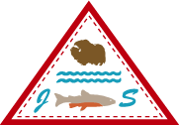

Joint Secretariat
Inuvialuit Settlement Region
Annual Activity Report

Introduction
The Joint Secretariat (JS) provides administrative and technical support to the six bodies established in Sections 11–14 of the Inuvialuit Final Agreement (IFA). These bodies include the Inuvialuit Game Council (IGC), Environmental Impact Screening Committee (EISC), Environmental Impact Review Board (EIRB), Fisheries Joint Management Committee (FJMC), Wildlife Management Advisory Council – NWT (WMAC (NWT)) and Wildlife Management Advisory Council – North Slope (WMAC (NS)). The JS was incorporated as a society in 1987 with the agreement of the parties to the IFA. The six chairs of the committees listed here constitute the society's members and directors.
The core duties of the Joint Secretariat are:
- To support and facilitate the interests and activities of the IFA committees established pursuant to Sections 11–14 of the Inuvialuit Final Agreement in any matters relating to their responsibilities and interests.
- To provide administrative (financial/clerical) support to IFA committees and to arrange logistics of meetings pursuant to the business therein.
- To record and make available all materials associated with the business of IFA committees as required by their Chairs and other appropriate agencies.
- To establish and maintain working liaisons between the Joint Secretariat and other Inuvialuit organizations, Government, Industry, the Academic sector and other relevant agencies or organizations.
- To provide technical resource support to IFA committees as required by their Chairs.
The JS administers all funding (receivable and payable) on behalf of IGC, EISC, EIRB, FJMC and WMAC (NWT). The majority of IFA committee funding is provided though Contribution Agreements with the Federal Government and Territorial Governments. Outside funding sources are also administered by the JS.
The JS administers Inuvialuit Participation Costs only on behalf of the WMAC (NS).
The JS administers all HR matters in support of IGC, EISC, EIRB, FJMC, and WMAC (NWT). The WMAC (NS) administers its own HR requirements.
Key stakeholders that the JS interacts with regularly in order to provide appropriate administrative and technical support include:
- Inuvialuit Regional Corporation (IRC)
- Inuvialuit Hunters and Trappers Committees (HTCs)
- Crown-Indigenous Relations and Northern Affairs Canada (CIRNA)
- Department of the Executive and Indigenous Affairs – Government of the Northwest Territories (DOEIA – GNWT)
- Department of Environment and Natural Resources – GNWT (ENR – GNWT)
- Department of Fisheries and Oceans Canada (DFO)
- Department of Environment – Yukon Government (DOE – YG)

Joint Secretariat Staff
As of March 31, 2018, the Joint Secretariat employed 14 full-time staff. Over the course of the fiscal year numerous casual staff have been hired as required. Please note that WMAC (NS) employs staff independently of the JS.

Administration Staff
Mike Harlow | Executive Director (until Sept. 2018)
Peter Enitilo | Office Manager (until July 2018)
Cheryl Williams | Interim Office Manager (effective August 2018)
Jennifer Lam | Committee Program Manager (effective Sept. 2018)
Arsalan Malik | Senior Finance Officer
Eunice Thrasher | Finance Officer
Shawna Kaglik | Travel Coordinator
Bernice Joe | Administrative Assistant

Committee Support
Jennifer Lam | IGC Resource Coordinator (until Sept. 2018)
Chanda Turner | IGC Resource Coordinator
Davonna Kasook | IGC Resource Coordinator (effective March 2018)
Michel Lindsay | EISC Coordinator
Lenora McLeod | EIRB Coordinator
Vanessa Cunningham | FJMC Resource Coordinator
Emily Way-Nee | FJMC Resource Coordinator
Jodie Maring | WMAC (NWT) – Resource Coordinator
Allison Thompson | WMAC (NWT) – Wildlife Biologist (until Oct. 2018)
Rosemin Nathoo | WMAC (NWT) – Wildlife Biologist (effective Nov. 2018)

Meeting Summary / Committee Makeup
During the 2018/2019 fiscal year the JS Board held the following meetings:
- April 24-25, 2018 – Vancouver, BC
- July 10, 2018 – Yellowknife, NT- Annual General Meeting
- July 11, 2018 – Yellowknife, NT
- August 2018 – teleconference
- September 18, 2018 - teleconference
- October 12, 2018 – teleconference
- December 13, 2018 – Ottawa, ON
The committee membership and directors are made up of the Chairs of the six IFA committees. The Chair of the JS Board is elected by the membership at the Annual General Meeting (AGM). Membership of the JS over the fiscal year was as follows:
Board Position | Name | Committee Position
JS Chair | Larry Carpenter | WMAC (NWT) Chair
JS Vice Chair | Vic Gillman (until Sept 2018) | FJMC Chair
Regular members | John Lucas Jr  (until July 2018) | IGC Chair
 | Vernon Amos (effective August 2018) | IGC Chair
 | David Livingstone | EISC Chair
 | John Donihee | EIRB Chair
 | Lindsay Staples | WMAC (NS) Chair
 | Alan Kennedy (effective Sept 2018) | FJMC Chair
Secretary | Mike Harlow  (until September 2018) | JS Executive Director
 | Vic Gillman (For Dec 2018 meeting) | Contractor

Committee Activities

Implementation of Joint Secretariat Organizational Review Recommendations
In the early part of the 2016/2017 fiscal year, the JS Board completed a third-party review of the organization’s structure and human resources realities, with a goal to identify where change could lead to improved achievement. The review produced 37 recommended actions that, if properly implemented, would lead to a better workplace environment, improved financial accountability, increased staff retention, and a more strategic approach to JS operations. These recommendations were reviewed and approved at the JS Board meeting on April 26, 2017. The majority of the approved implementation actions have either been completed or initiated with promising results.

Improved Financial Management
The overall financial management of the JS has been evaluated and adjusted to increase financial accountability. Key steps taken include ensuring the JS Board is provided with regular financial updates so it is fully aware of the organization’s financial situation. To consolidate and streamline budgeting the IFA committees and JS now follow a standard budgeting process that will help produce a single JS budget for approval by the Board. Internally, new processes related to expenditure approvals have been put in place to ensure proper review and coding. An interim audit to better understand the overall financial situation was undertaken in January. The audit highlighted needed areas of improvement related to bank reconciliations and bill-back accounts and prepped the finance team for the annual audit. Finally, a Contribution Agreement (CA) review process has been implemented to ensure key staff are fully aware of the CA prior to entering into potentially difficult arrangements. These and similar efforts are improving JS financial accountability.
The JS finance team must be commended on its efforts to maximize allocations of reasonable and defendable core expenditures against previously accumulated surplus amounts and stand-alone contribution agreements.

Day-to-day Activities
Over the course of the fiscal year, the normal day-to-day operations of the JS and IFA committees have been supported and advanced. Related responsibilities include: financial accounting and management, carrying out payroll, making travel bookings, addressing IT and infrastructure needs, regularly communicating with regional partners (especially IRC), and other regularly occurring tasks associated with running the JS office.
Committee Program Manager Position
The Joint Secretariat added an additional position to the JS management team. Jennifer Lam was promoted to the position of Committee Program Manager (CPM). Jennifer has been an employee with the Joint Secretariat since 2008 and has worked with a number of the boards as staff support. This position was created to provide overall management supervision for the Resource Person (RP) team that supports the committees and boards. In addition to providing leadership to the RP team, this position was developed to ensure effective collaboration between the RPs and better coordination between the IFA boards. This position will also work to develop effective and open relationships between the Joint Secretariat, the boards it supports and key partners and stakeholders.
Since taking the position, the CPM has begun developing a framework for RP staff orientation and professional development. There are regular RP meetings to help increase coordination and communication amongst staff. The CPM has implemented a quarterly workplan review between RPs and the Chairs of the boards they support. The CPM has begun developing a RP training curriculum to ensure that RPs have the appropriate support and capacity to fulfill their positions.

Funding Summary
In the 2018/2019 fiscal year, the Joint Secretariat (JS) received funding from various sources. The majority of funding is provided via contribution agreements (CA) with Crown-Indigenous Relations and Northern Affairs Canada (CIRNA) and the Government of the Northwest Territories – Environment and Natural Resources (GNWT–ENR). The remainder of received funding was provided through contributions made by other federal and territorial government departments, the Inuvialuit Regional Corporation (IRC), and non-governmental organizations. These funds were managed by the JS on behalf of the six committees established in sections 11–14 of the Inuvialuit Final Agreement (IFA). Committee operations are supported by budgets established and overseen through motion of individual committees.
As a body independent of the IFA committees, the JS is provided its own operating budget. The general expenditures associated with the JS include compensation for communal staff, certain communal costs, specific projects, and other expenditures better accounted for by the Joint Secretariat, as summarized in annual audits.

Overall Summary
The Joint Secretariat has taken meaningful steps to put the “joint” back in the Joint Secretariat. Strategic investment in new positions and better support for existing ones will ensure the JS continues to grow in the positive direction it has moved over the past year.

Joint Secretariat Resource Staff Activity Reports
Inuvialuit Game Council Resource Management Coordinators Activity Report
Chanda Turner was employed as a Resource Management Coordinators (RMC) for the duration of March 2018-19. Jennifer Lam was also an RMC from March 2018 to September 2018. Davonna Kasook was in the RMC position from March 5th – 31st 2019.
Much of RMC activities involve the day-to-day management of the affairs of the Inuvialuit Game Council (IGC), especially for the Chair of the IGC. This includes writing, managing and filing correspondence, reviewing and developing documents, preparing travel arrangements and information packages for any of the members or other representatives attending meetings/conferences, participating in conference calls, and the planning of various meetings. IGC meetings are held quarterly with the RMCs preparing the meeting packages, taking the minutes for each meeting and completing the action items coming out of those meetings. All four quarterly meetings were held in 2018-19.
The RMC’s coordinated IGC input into federal legislative reviews and prepared presentations for IGC directors to the Expert Panels. They were also involved in coordinating the legal review of proposed changes to several GNWT Legislative Acts. Chanda took part in the GNWT Wildlife Act WG meeting and Section 15 meeting.
The RMCs participated in a number of meetings focused on polar bear management, such as the Polar Bear Technical Committee and Polar Bear Administrative Committee meetings, as well as ‘Inuit Communication Group’ meetings with representatives from other Inuit regions in Canada and the federal and Territorial governments. They were also involved in the development of federal Polar Bear Management Plan. The Inuvialuit Game Council hosted in the Inuvialuit-Inupiat Polar Bear Joint Commission and the Inuvialuit-Inupiat Beluga Whale Joint Commission meetings in Edmonton, AB. IGC and RMCs have been involved in the planning for the next round of polar bear population surveys for the North and South Beaufort Sea Populations.
The RMCs also attended the ArcticNet Science Meeting, the NWT Pests, Pathogens, and Invasive Species Symposium, the North American Caribou Workshop, along with IGC directors to share the Inuvialuit perspective and to gain further knowledge on a range of arctic environmental and wildlife issues.=
The RMCs participated and assisted with various meetings related to the region including the Beaufort Sea Partnership meetings, the Beluga Co-Design Workshop, Porcupine Caribou Annual Harvest Meeting and the Inuvik-Tuktoyaktuk Highway Corridor Working Group meetings, CMAC meetings, ICC Alaska Food Sovereignty and Self-Governance meetings, various WG meetings, Inuit Communications Group meeting, Proactive Vessel Management meeting, among others.
Jennifer and Davonna assisted and participated in joint community tours to gather community feedback for the Beaufort Regional Strategic Environmental Assessment (BRSEA) and communicate results of the Assessment process to date. They are engaged, along with the Chair, in the decision-making process for the development of the Assessment, and the inclusion of traditional knowledge and scientific knowledge.
Jennifer and Davonna were involved in numerous co-design initiatives for beluga research, including the successful first year of a tagging program operated out of Hendrickson Island.
Jennifer was the primary organizer of an ISR-wide Shipping Workshop in June 2018 to set priorities for shipping management in the ISR, and she and Davonna have been engaged in numerous initiatives related to shipping through the Oceans Protection Plan and working with World Wildlife Fund Canada.
Chanda has worked on bringing people together to develop the Inuvialuit position on sensitive habitat management for the barren-ground caribou herds (Tuktoyaktuk Peninsula & Cape Bathurst), as this will be required when the species is listed under SARA by ECCC. She has also been involved in planning user-to-user meetings among organizations in Nunavut and NWT for the management of Dolphin & Union Caribou, and coordinating consultations from ECCC in the communities of Paulatuk and Ulukhaktok regarding the potential uplisting of this species. She represented IGC on the working group for boreal caribou range planning in northern NWT, and is part of the technical working group of the Parties to the Porcupine Caribou Management Agreement. She was part of the team who wrote submissions to the Alaska Bureau of Land Management regarding the Environmental Impact Assessment process for the proposed development in ANWR.

Wildlife Management Advisory Council Staff Activity Report
Resource Coordinator Report
The Resource Coordinator is responsible for administering the office operations of the Wildlife Management Advisory Council (NWT), which includes coordinating meeting and travel logistics for the Council meetings and/or when attending or hosting meetings and conferences, develop and distribute meeting material packages, producing meeting minutes and notes, maintain actions items, managing and filing correspondence, records and analyze basic finance management and develop projected budgets for the Council and associated projects, coordinate and corresponds the wildlife regulation by-laws with other organizations, assist on presenting wildlife management and wildlife related matters to the ISR communities, and project management.
The Resource Coordinator also collaborates with organizations such as hunters and trappers’ committees, territorial and federal governments wildlife departments, and other wildlife management boards.
Wildlife Biologist Report
The Wildlife Biologist supports the work of the WMAC (NWT) related to species at risk within the Inuvialuit Settlement Region. This involves providing technical advice to the Council to meet its mandate on all matters relating to wildlife policy and the management, regulation, research, enforcement and administration of wildlife, habitat and harvesting for the Western Arctic Region. They are also the primary point of contact for the WMAC (NWT) for information on species at risk. This year, Allison Thompson worked as the wildlife biologist until October 3, 2018 and Rosemin Nathoo began the position on November 19, 2018.
The biologist reviews and provides comments for WMAC (NWT) approval on wildlife legislation and regulations, including COSEWIC and NWT Species at Risk (SARC) status reports. They also review and provide technical advice on the consultation requirements for development of applicable management plans for wildlife or recovery strategies for relevant national and NWT species at risk. In 2018-2019, these documents have included the COSEWIC polar bear status report, three SARC bumble bee status reports, the federal polar bear management plan, the federal hairy braya recovery strategy, the NWT barren-ground caribou recovery strategy, the GNWT boreal caribou range planning framework, and ACCWM action plans, and the GNWT Wildlife Act. Allison Thompson prepared materials for the WMAC (NWT) community tour (and participated in the tour until her term ended) and attended meetings for the development of the boreal caribou range planning framework, ISR shipping workshop, community implementation meetings, CARMA, Wildlife Act working groups, and IFA101.
The biologist provides technical staff input and support at meetings related to wildlife in the Western Arctic Region; those meetings are outlined below. They are also responsible for tracking the commitments of the Council in terms of implementation of management plans, recovery strategies, and action plans for ISR wildlife. This involves project management, funding proposals, and the coordination of activities (e.g. a plant/insect Bioblitz on Banks Island, the development of an Inuvialuit-led position paper on sensitive habitat management for barren-ground caribou, the reopening of a traditional knowledge project on caribou on Victoria Island). Funding proposals this year included the Aboriginal Fund for Species at Risk (for Dolphin and Union Management Plan implementation), Polar Knowledge Canada (to facilitate the co-design of the next Dolphin and Union population survey), and the SAR(NWT) Stewardship Fund (to complete a caribou traditional knowledge project).

Meeting and Conferences Participation

During the 2018/2019 fiscal year, the Resource Coordinator and Wildlife Biologist attended ACCWM annual status meetings, communication and education working group teleconferences, and working group teleconferences and meeting, CMA meetings and teleconferences, Species at Risk committee meeting, polar bear technical committee meeting, Inuvik-Tuktoyaktuk highway corridor working group meetings, beaver management teleconference, WMACs Joint meetings, WMAC (NWT) Species at Risk community tour, WMAC (NWT) quarterly meetings, Arctic Net conference, Tuk Pen and Cape Bathurst working group meetings, Dolphin and Union user-to-user meetings and teleconferences, and Inuit-Inuvialuit polar bear commissioners (Northern Beaufort) meeting.

Fisheries Joint Management Committee Staff Activity Report
The Fisheries Resource Coordinator is responsible for providing technical and administrative support to the Fisheries Joint Management Committee (FJMC) in order to conserve and protect fish and marine mammals and their habitats in the Inuvialuit Settlement Region (ISR).
The Resource Person (RP) planned and coordinated 4 quarterly meetings for the FJMC in the 2018-2019 fiscal year. The meetings included research proposal presentations, budget planning, program updates and decisions, meeting and conference discussion and review of various documents and correspondence.
The RP participated in a number of meetings focused on beluga whale management, such as the Second International Workshop on Beluga Whale research and conservation, the Inuvialuit-Inupiat Beluga Whale Commission meeting, various Tagging Advisory Group meetings and teleconferences and a co-design workshop for the development of beluga tagging methods and procedures.
The RP also attended ArcticNet Science Meeting and organized a Co-management booth to network and gain further knowledge on a range of arctic environmental and fisheries issues. The RP also organized a meeting with the Minister of Fisheries and Oceans to discuss local and regional issues and priorities with regards to fish and marine mammal management in the ISR. Additionally, the RP assisted and participated in the Arctic Co-management workshop, which included representatives from the 4 fish and wildlife co-management boards from across the Canadian Arctic, that came together to discuss common issues and concerns and develop a unified voice moving forward.
The RP participated and assisted with various meetings including the Beaufort Sea Partnership meetings, Regional Strategic Environmental Planning meetings, Arctic Char community working group meetings, Shipping in the ISR workshop, etc.

Environmental Impact Screening Committee Staff Activity Report
The EIS Coordinator is responsible for providing administrative support to the EISC for all day to day business, meetings, and ongoing projects. The Coordinator position was fully occupied during the period of this report.
Projects
Recognizing that the roles and responsibilities of the EISC were not widely understood throughout the Inuvialuit Settlement Region, the EIS Coordinator, along with EIRB Coordinator, organized the first Community Tour held by the EISC in nearly a decade. The Environmental Impact Review Board was also included on the Community Tour in order to provide a broader view of the Environmental Impact Assessment process from start to finish in the region. This Community Tour was split into two parts. The first part of the Community Tour which was held in March 2019 included presentations in Inuvik, Aklavik, and Tuktoyaktuk. The second part of the Community Tour (tentatively scheduled for October or November 2019) will include presentations in Sachs Harbour, Ulukhaktok, and Paulatuk.
The EIS Coordinator has been working with the Communication, Information, and Technology Coordinator for the JS in order to update the EISC website and Registry. The EISC Registry is our online database repository for projects that are proposed for work within the Inuvialuit Settlement Region (ISR). The EISC Registry and website is dated and requires multiple database deficiencies to be addressed. It is expected that the new Registry will also be more “user friendly” and more transparent. Interested parties will no longer have to be registered users in order to gain access to publicly available documents they will simply just have to proceed to the Registry documents.
As the EIS Coordinator, it is important to have a good understanding of what ‘Environmental Impact Assessment’ (EIA) means but also how EIA functions from jurisdiction to jurisdiction. For this reason, the EIS Coordinator registered and successfully completed an online course on the ‘Foundations of Impact Assessment’ offered through the International Association on Impact Assessment which ran from June 2018 to August 2018.
EISC Meetings
The EIS Coordinator is responsible for all arrangements relating to the EISC meetings; which occur every six (6) weeks. This work includes - but was not limited to - overseeing travel and accommodation requirements, honoraria and per diem management, meeting package preparations (agenda, minutes, etc.), boardroom booking / catering bookings, minute taking, guest presentations coordination, resolution tracking, etc.
From April 1st, 2018 – March 31st, 2019, the following EISC meetings have occurred:
1. | April 26th, 2018 | Inuvik, NT
2. | June 7th, 2018 | Inuvik, NT
3. | July 19th, 2018 | Inuvik, NT
4. | August 30th, 2018 | Inuvik, NT
5. | October 11th, 2018 | Inuvik, NT
6. | November 22nd, 2018 | Inuvik, NT
7. | December 20th, 2018 | Teleconference
8. | January 31st, 2019 | Inuvik, NT
9. | March 12th & 15th, 2019 | Inuvik, NT

Other Meetings
The EIS Coordinator was also involved in attending meetings held by various governments, regulatory authorities, non-governmental organizations, and Inuvialuit bodies where current information on the EIS guidelines and activities were provided by the Coordinator or the EISC requested the Coordinator to attend in an effort to stay current on relevant issues faced within the Inuvialuit Settlement Region.
 | Meeting | Date | Location
1. | Boreal Range Planning Framework | July 24-25th, 2018 | Yellowknife, NT
2. | ISR Shipping Coordination Workshop | June 25-27th, 2018 | Inuvik, NT
3. | Prairie and Northern Region Canadian Marine Advisory Council (PNR CMAC) | November 27-28th, 2018 | Yellowknife, NT
4. | IGC Meeting | December 5-6th, 2018 | Inuvik, NT
5. | Arctic Net 2019 | December 10-14th, 2018 | Ottawa, ON
6. | IWB Water and Waste Management Workshop | February 6-7^{th,} 2019 | Inuvik, NT
7. | IGC Meeting | March 7-8th, 2019 | Inuvik, NT
8. | Proactive Vessel Management for the ISR | November 22nd, 2018 | Inuvik, NT

For the time period covered for this report, the EIS Coordinator has also attended monthly Resource Person (RP) meetings. These meetings are attended by the resource staff for each of the five JS co-management boards, the resources staff for the IGC, and the Shared Services Unit. The meetings are held to: share ideas, compare calendars, identify collaborative project possibilities, and to discuss any other relevant concerns/issues that can be best addressed as a group.

Environmental Impact Review Board Staff Activity Report
A majority of the activities overseen by the Resource Coordinator (RC) includes the day-to-day management for the Environmental Impact Review Board (EIRB) matters. This includes writing, managing and filing correspondence, reviewing documents, preparing travel arrangements and information packages for members participating in meetings/conferences, participating in conference calls and various meetings. EIRB meets quarterly which the RC prepares the meeting package, taking of minutes for each meeting and completing action items which come out of the meeting.

The RC participates in monthly teleconferences with the EIA Improvement Initiative working group and keeps current with matters from the NWT Board Forum, PanTerritorial, ArcticEIA and Mackenzie Valley Resource Management Act.
The RC also attended the ISR Shipping Workshop and ArcticNet Science Meeting.
The RC, along with members of the EIRB, participated in a community tour which visited Aklavik, Inuvik, and Tuktoyaktuk. The community tour shared information on the screening and review process in the Inuvialuit Settlement Region (ISR) that derives from the Inuvialuit Final Agreement (IFA).

Marine Protected Area Coordinator Activity Report
The marine protected area (MPA) coordinator worked collaboratively with the Department of Fisheries and Oceans (DFO) and the Hunters and Trappers committees of Aklavik, Inuvik, Paulatuk, and Tuktoyaktuk to establish the MPA specific working groups in early 2018. In addition to coordinating the daily activities of the MPA specific working groups, the MPA coordinator also assists DFO – Oceans (Inuvik) with administration of the Western Arctic Marine Protected Area Steering Committee. Activities involved in Working Group and Steering Committee meeting planning include the development of agendas, meeting materials, and minutes as well as coordination of hospitality and WG member payments.
The MPA coordinator assisted DFO in the planning and facilitation of two Anguniaqvia niqiqyuam MPA (ANMPA) working group meetings during the 2018-2019 fiscal year. The purpose of these meetings was for ANMPA WG members to review and provide feedback on 2019-2020 proposed research and monitoring activities for the ANMPA. The review exercise was facilitated by a project ranking form developed by the MPA coordinator. The Tarium Niryutait MPA (TNMPA) working group held one meeting in early 2019 to also provide their feedback on TNMPA related research and monitoring proposals using the same ranking form.
The MPA coordinator participated in the five-year review of the TNMPA management and monitoring plans led by DFO – Oceans (Inuvik). This included assistance in the planning and hosting of meetings with the HTC’s of Aklavik, Inuvik, and Tuktoyaktuk to conduct the socio-economic questionnaire with participants. The MPA coordinator also assisted in the drafting and review of the Technical Report of Fisheries and Aquatic Sciences “State of the Tarium Niryutait Marine Protected Area: Inventory of monitoring from 2010-2016” that is currently under review by DFO.
The MPA coordinator attends multiple meetings of the FJMC, including the January FJMC/WAMPA meeting in Winnipeg, the FJMC June community tour and the September HTC presidents meeting. In addition, the MPA coordinator attended multiple conferences in 2018-2019 including the Arctic Biodiversity Congress held in Rovaniemi, Finland in October 2018 on behalf of IRC. During this conference the MPA coordinator made a presentation about Inuvialuit leadership in Marine protected area establishment and management in the Inuvialuit Settlement Region. The MPA coordinator also attended the annual ArcticNet Conference in Ottawa in December 2018 as an observer and provided an update to MPA working groups on the presentations and panels attended.

Additional activities of the MPA coordinator in 2018-2019 included administration of 2018-2019 contracts for approved MPA research and monitoring activities; facilitation of the transition of the Arctic Observer Application from DFO to the JS; participation in updating the Beluga Tourism Guidelines; promotion of coordination between Inuvialuit and Federal harvest monitoring programs within the MPAs; completion of annual review/newsletter for the ANMPA; and facilitation of research proposal development and submission by PHTC to address community priorities of invertebrate and whitefish.

Traditional Local Knowledge Coordinator Activity Report
- RSEA TK PROJECTS
  - There were three traditional and local knowledge as part of Beaufort Regional Strategic Environmental Assessment (BRSEA) that the TLK Coordinator led. All three projects, Inuvialuit Place Names, The Importance of Ice, Inuvialuit Cultural Life Out on the Land and Assessment of Key Species of the Beaufort are strategically coordinated to fill gaps in existing traditional knowledge research.

- Inuvialuit Place Names:
  - The goal is to create a centralized map of the traditional Inuvialuit place names within the Inuvialuit Settlement Region (ISR). The TLK coordinator has completed compiling a list of research projects that would contain place name information.
  - At this stage there is a post-doctoral candidate working on the project based out of the Prince of Wales Heritage Museum.
- Understanding the Importance of Sea Ice:
  - The goal of this project it to identity key relationships between ice, species health/movements, transportation, harvest and culture.
  - Final report with revisions completed May 1st, 2019.
- Inuvialuit Cultural Life Out on the Land:
  - The goal of this 1.5-year study is to establish the importance of harvest as a cultural activity within the ISR. 116 interviews completed in the 6 ISR communities.
  - Data collection completed September 15th, 2019.
  - Transcriptions of audio recordings completed December 1st, 2019,
  - Analysis of transcriptions completed February 29th, 2019,
  - Verification survey completed April 15th, 2019,
  - Verification of transcriptions completed May 19th, 2019,
  - Final report completed May 1st, 2019.

- ISR Traditional Knowledge Policy
- Draft of this policy was presented to Game Council in December 2018.
- This draft was endorsed by Game Council in a resolution.
- IRC legal reviewed and provided feedback on Policy.
- TLK Working group
  - Coordination and facilitation of 2-day of a TLK WG meeting,
  - Facilitated policy review workshop and workplan discussion.
- Coordination and liaison with researchers
  - Review various research projects and provide feedback,
  - Receive copies of the research licenses during the ARI review process.
- Meetings & presentations
  - FJMC presentation, February 1st, 2018.
  - Attended Arctic Net conference.
  - RSEA Arctic Net Side Meeting presentation, December 10th, 2018.
  - WMAC presentation, November 29th, 2018.
  - ERIB presentation, November 5th, 2018.
  - Inuvialuit Game Council presentation, November 16th, 2018.
  - Beaufort Sea Partnership presentation, October 24th, 2018.
  - Organized TLK Working Group Meeting, October 25 & 26th, 2018.
  - Regional Coordination Committee Presentation, October 6th, 2018.
  - Inuvialuit Game Council Meeting, September 1st, 2018.
  - EISC Presentation, July 19^{th,} 2018.

Community Based Monitoring Program Staff Activity Report
This past year was again one of transition and development. Despite challenges arising from the IRC to Joint Secretariat transition, 2018-2019 was an important year of building a strong foundation for CBMP growth in 2019-2020. Increasing and improving communication and coordination with co-management and external research activities was prioritized. Therefore, actively participated in co-management and IGC meetings through both in-person presentations and written updates. The CBMP Coordinator spent more time building relationships and networking with academic and government research activities, with the goal of building partnerships between CBMP and external monitoring initiatives. The CBMP Coordinator also continued to keep IRC abreast of CBMP activities through quarterly updates and ongoing communications with Jenn Parrott, IRC Research Manager. She attended ArcticNet in December 2018, as well as various regional meetings ranging from HTC to the Beaufort Sea Partnership.
The CBMP Coordinator continued to maintain the Inuvialuit Harvest Study through ongoing relationships with all six Hunters and Trappers Committees. This work includes fund acquisition, budget tracking, developing contracts with HTCs, and supporting HTCs in program administration. Moreover, she maintained the dataset through our verification process; managed CBMP assets and troubleshooted the technology; and responded to data requests. Additionally, she worked on and completed the Traditional Knowledge Assessment for Key Species of the Beaufort Sea as part of the Regional Strategic Environmental Assessment. This project included surveys, interviews and mapping data, all of which needed to be digitized and organized. Following data collection was the data verification component, which happened online through a custom platform that she coordinated. In addition to the TLK project, another part of the CBMP Coordinator’s work on RSEA was organizing the annual RSEA/CBMP Community Tour, which included outreach and meetings in all six communities. She took it upon myself this year to create a plain language summary document of all RSEA funded research to distribute on the community tour.
In 2018-2019, the CBMP Coordinator worked on a funding proposal for the Indigenous Community-Based Climate Monitoring Program, which was unsuccessful. However, we have received funds from this agency in 2019-2020. She also worked on a funding application for the Inuvialuit Guardians program, which was successful and that project will commence in the fall of 2019.

The Wildlife Management Advisory Council (North Slope) will report independently.
As set out in the Inuvialuit Final Agreement under Section 11.(22)

